
CSA15 – CLOUD COMPUTING AND BIG DATA ANALYTICS

ASSIGNMENT 1 – CO1
Design, Analyse and Validate a Cloud-Based Solution for Migrating a Legacy University Management System
CO1: Apply cloud computing technologies including hardware–software evolution, virtualization, web services, and service models to develop cloud-based solutions.

Field | Details | Field | Details
Student Name | M. Srilakshmi | Register Number | 192525404
Department / Section | Btech AIML | Academic Year / Semester | 2nd
Faculty Name | Latha R | Nature of Assignment | Individual
Duration | 1 Week | Total Marks | 50
Submission Date |  | Evaluation Date

MARK SHEET (Rubric-based evaluation)
Task | Title | Max | Awarded | Evidence / evaluation focus
1 | Introduce Cloud Computing | 3 |  | Definition; characteristics; deployment models; scenario mapping
2 | Trace Evolution and Hardware Evolution | 3 |  | Timeline; hardware evolution; relevance to university
3 | Analyse Internet Software Evolution | 3 |  | Web/software evolution; SOA; APIs; scenario relevance
4 | Apply Server Virtualization | 5 |  | Hypervisor types; VM/container comparison; consolidation; limitations
5 | Apply Web Services | 4 |  | SOA and SOAP/REST; three university APIs; request/response examples
6 | Analyse IaaS, PaaS and SaaS | 5 |  | Responsibility layers; five-application mapping; comparison; providers
7 | Examine XaaS | 3 |  | Four or more variants; two justified choices; provider risks
8 | Design Cloud Solution Architecture | 5 |  | Labelled diagram; deployment/service models; scaling; security; DR
9 | Hands-on Implementation and Documentation | 4 |  | Running VM/container; PaaS/SaaS; tests; actual screenshots
10 | Evaluate and Recommend Final Solution | 7 |  | Three-way comparison; 3-year costs; risks; phased roadmap
11 | Day-4 Design Challenge | 8 |  | Impact; evaluation; adaptation; evidence-based defence
 | TOTAL | 50 |  | Percentage :

EVIDENCE VERIFICATION CHECKLIST

Tasks | Evidence expected | Status (✓ / P / ✗) | Evaluator note
1–3 | Conceptual explanations, comparisons and relevant illustrations | ✓ | Explanations and relevant scenario mapping documented
4 | Virtualization calculations with stated assumptions and peak-load caution | ✓ | Calculations present; practical capacity validation recommended
5–7 | API examples, service responsibility table and justified XaaS choices | ✓ | Required conceptual evidence documented
8 | Labelled architecture diagram, caption below figure and component justification | ✓ | Architecture documented; sizing assumptions need testing
9 | Actual code, environment details, execution logs, API outputs and screenshots | P | Procedures provided; actual execution evidence not established
10 | Cost assumptions, 3-year totals, risk controls and migration roadmap | ✓ | Estimates and rationale documented
11 | Day-4 changes, 10× load strategy, 99.9% target and 40-college isolation | ✓ | Design analysis documented; practical validation pending

IMPLEMENTATION EVIDENCE CHAIN

Evidence item | Status | Observation
Source code | ✓ | Flask REST API and Dockerfile provided in the proposed implementation
Virtualization | P | Docker container configuration documented; running-container evidence required
PaaS or SaaS | P | Managed web-service deployment procedure described; live deployment not verified
Functional test | P | Expected HTTP 200 response and JSON output documented; actual output required
Failure case | P | HTTP 404 test case documented; actual execution record required
Screenshots | P | Screenshot requirements identified; authentic screenshots need verification
Reproducibility | ✓ | Build commands, run commands, endpoints and expected results specified

OVERALL REMARKS

_______________  Student Signature | _______________  Faculty Signature | _______________  Program Director
MANDATORY SUBMISSION EVIDENCE CHECK
✓ = Present in documented answer; P = Partly present; ✗ = Missing / not satisfied
Task | Evidence expected | Status | Evaluator note
1 | Cloud definition, characteristics, deployment models and scenario mapping | ✓ | All conceptual requirements covered
2 | Evolution timeline, hardware development and university relevance | ✓ | Well explained with relevant examples
3 | Internet software evolution, SOA and APIs | ✓ | Clear explanation and scenario relevance
4 | Hypervisors, VM/container comparison and consolidation calculations | ✓ | Calculations included; peak-load limitations discussed
5 | SOAP/REST comparison and three university APIs | ✓ | API methods and request/response examples documented
6 | IaaS/PaaS/SaaS responsibility layers and application mapping | ✓ | All five applications categorized with justification
7 | XaaS variants and two justified selections | ✓ | Six variants explained; DBaaS and DRaaS recommended
8 | Labelled architecture, scaling, security and disaster recovery | ✓ | Design and component justifications documented
9 | Working container, PaaS/SaaS deployment, actual tests and screenshots | P | Code and procedures provided; actual execution evidence requires verification
10 | Three-year cost comparison, risks and migration roadmap | ✓ | Cost assumptions, calculations and recommendations included
11 | Impact analysis, 10× load, 99.9% availability and tenant isolation | ✓ | Changed requirements evaluated; load-test evidence recommended

IMPLEMENTATION EVIDENCE CHAIN
Evidence item | Status | Observation
Source code | ✓ | Python Flask REST API and Dockerfile documented
Virtualization | P | Docker build and run procedures provided; execution screenshot required
PaaS or SaaS | P | Cloud deployment steps described; actual deployment confirmation required
Functional test | P | HTTP 200 and expected JSON response documented; actual test output required
Failure case | P | HTTP 404 test case included; execution evidence required
Screenshots | P | Required screenshots identified but authenticity and completeness not verified
Reproducibility | ✓ | Installation, configuration, commands and testing steps documented
Interpretation | ✓ | Technical outcomes and implementation limitations explained
Code and report consistency | ✓ | Proposed API, Docker configuration and testing procedure are aligned

SUBMISSION CHECKLIST (Not Separately Marked)
Requirement | Status
All 11 tasks answered | ☒ Yes ☐ Partly ☐ No
Cloud concepts and comparisons explained | ☒ Yes ☐ Partly ☐ No
Virtualization calculations included | ☒ Yes ☐ Partly ☐ No
API examples and service models explained | ☒ Yes ☐ Partly ☐ No
Cloud architecture diagram included | ☒ Yes ☐ Partly ☐ No
Implementation and testing evidence provided | ☐ Yes ☒ Partly ☐ No
Three-year cost analysis and roadmap included | ☒ Yes ☐ Partly ☐ No
Day-4 design challenge completed | ☒ Yes ☐ Partly ☐ No
Figures and screenshots included | ☐ Yes ☒ Partly ☐ No
Table and figure numbering correct | ☐ Yes ☒ Partly ☐ No
Viva recommended | ☒ Yes ☐ No

CSA15 – Cloud Computing and Big Data Analytics
ASSIGNMENT 1
CO1: Apply cloud computing technologies including hardware–software evolution, virtualization, web services, and service models to develop cloud-based solutions.

Assignment Title: Design, Analyse and Validate a Cloud-Based Solution for Migrating a Legacy University Management System (Total Marks – 50)
Duration: 1 week
Scenario – Smart Campus Cloud Migration
A multi-campus university currently runs its Student Information System, Learning Management System, Library System, Exam Portal and Email on ageing physical servers in a single on-premise data centre. Each application has its own dedicated server, which stays idle for most of the year but fails to cope during admissions, result publication and online-exam weeks.
The university's current environment is:
- 12 physical servers, average CPU utilisation of about 15%, with peaks above 95% during admissions and exams
- Approximately 25,000 students and 2,000 staff across 4 campuses
- Applications built as large monolithic programs, with no public interfaces for mobile apps or partner colleges
- High capital expenditure, slow procurement (6–8 weeks per server) and no disaster recovery site
As a cloud consultant, you must study how computing evolved to the cloud model, and then design a cloud-based solution that uses virtualization, web services and an appropriate mix of service models (IaaS, PaaS, SaaS and XaaS) for the university. All recommendations must be justified in terms of cost, scalability, availability and manageability.
Design Challenge:
On Day 4, the university announces that it will launch a mobile app and open student-record and fee-payment services to 40 affiliated colleges. Expected load is 10 times the current peak, with a requirement of 99.9% availability and a limited operating budget. Re-evaluate your original design and decide whether it should be retained, modified or redesigned.
TASK 1 – Introduce Cloud Computing and Map It to the Scenario (3 Marks)
Design and Propose cloud computing model for the context of the university's problems.
- Definition of cloud computing and the five essential characteristics (on-demand self-service, broad network access, resource pooling, rapid elasticity, measured service)
- Deployment models (public, private, hybrid, community) and which one suits the university
- Three problems of the current on-premise setup and how each cloud characteristic addresses them
- Benefits and limitations of cloud adoption for the university
Evidence Expected
A clear explanation of cloud characteristics and deployment models, mapped to the university's actual problems.
TASK 2 – Trace the Evolution and Hardware Evolution (3 Marks)
Trace how computing infrastructure evolved to make cloud computing possible.
- A timeline from mainframes, minicomputers and PCs, to client–server, clusters, grid computing, utility computing and cloud
- Hardware evolution: multi-core processors, commodity servers, high-capacity storage, high-speed networking and data centres
- How each stage solved a limitation of the previous one
- Which stage the university's current system corresponds to, with reasons
Evidence Expected
A labelled timeline or diagram, with a justified explanation of how hardware advances enabled the cloud.
TASK 3 – Analyse Internet Software Evolution (3 Marks)
Explain how internet software evolved and why it supports cloud services.
- Evolution from static web pages to dynamic web, Web 2.0, SOA, mashups and cloud-hosted applications
- Role of browsers, HTTP, AJAX and APIs in delivering software over the internet
- Comparison between desktop software, client–server software and web-delivered software
- How this evolution affects the design of the university's applications
Evidence Expected
A comparative explanation of software evolution stages, linked to the university's application design.
TASK 4 – Apply Server Virtualization (5 Marks)
Apply server virtualization to consolidate the university's 12 physical servers.
- Explain how a hypervisor works, and distinguish Type-1 and Type-2 hypervisors, with examples
- Compare full virtualization, para-virtualization, OS-level virtualization (containers) and hardware-assisted virtualization
- Propose which applications should run as virtual machines and which as containers, with reasons
- Calculate the consolidation: with an average utilisation of 15% per server and a target host utilisation of 70%, estimate how many physical hosts are needed (show your assumptions and working)
- Discuss live migration, snapshots and resource over-commitment as benefits, and the risks of virtualization (noisy neighbour, hypervisor failure, security isolation)
Show your calculation. A final number without working will not receive full credit.
Evidence Expected
A justified virtualization plan with a worked consolidation calculation and discussion of benefits and risks.
TASK 5 – Apply Web Services (4 Marks)
Analyse web services to expose the university's functions to other systems.
- Overview of web services and their role in cloud and SOA
- Compare SOAP, WSDL, UDDI and RESTful services (HTTP methods, JSON/XML)
- Identify at least three university functions to expose as web services (for example, result lookup, fee payment, library search) and define the endpoint, method and sample request/response for each
- Justify whether SOAP or REST is more suitable for each function
Evidence Expected
A defined set of web services with sample request/response formats and a justified choice of SOAP or REST
TASK 6 – Analyse the Service Models: IaaS, PaaS and SaaS (5 Marks)
Analyse which service model fits each university application.
- Define IaaS, PaaS and SaaS, and show who manages which layer (hardware to application) in each model
- Categorise the five university applications (SIS, LMS, Library, Exam Portal, Email) into IaaS, PaaS or SaaS, with reasons
- Compare the models on control, cost, scalability, maintenance effort and vendor lock-in
- Give one real provider example for each model
Present your categorisation in a table, but explain the reasoning behind each decision. A table alone is not sufficient.
Evidence Expected
A reasoned mapping of applications to service models, supported by a layer-wise responsibility comparison.
TASK 7 – Examine XaaS (3 Marks)
Examine the broader XaaS (Anything-as-a-Service) concept for the university.
- Explain XaaS and describe at least four variants (for example DaaS, BaaS/MBaaS, FaaS, DBaaS, Security-as-a-Service, Disaster-Recovery-as-a-Service)
- Select two XaaS offerings that would benefit the university, and justify them
- Discuss the risks of over-reliance on multiple 'as-a-Service' providers
Evidence Expected
An analysis of XaaS variants, with justified selection of two offerings for the university.
TASK 8 – Design the Cloud Solution Architecture (5 Marks)
Bloom's Level: Level 6 – Create | Action verbs: Design, Construct, Propose
Create a complete cloud architecture for the university by combining virtualization, web services and service models.
- An architecture diagram showing users, load balancer, web/application tier, database tier, storage, API layer and DR region
- The deployment model and the service model chosen for each component
- How elasticity (auto-scaling) will handle admissions and exam peaks
- Basic security and availability measures (access control, encryption, backup, multi-zone deployment)
Evidence Expected
A labelled architecture diagram with written justification for each component and design decision.
TASK 9 – Hands-on Implementation and Documentation (4 Marks)
Implement a small proof-of-concept of your design using a free-tier cloud account or a local virtualization tool.
- Create a virtual machine or container (using AWS/Azure/GCP free tier, VirtualBox, or Docker) and host a simple web page or REST API for one university function
- Deploy a SaaS or PaaS component (for example a cloud-hosted database, a serverless function or a static site)
- Test the web service with a client (browser, Postman or curl) and record the output
- Provide screenshots, configuration steps and any issues faced
Evidence Expected
Annotated screenshots and clear, reproducible steps showing that the proof-of-concept works.
TASK 10 – Evaluate and Recommend the Final Solution (7 Marks)
Evaluate your design and recommend the final cloud solution for the university.
- Compare on-premise, IaaS-based and PaaS/SaaS-based options on cost (CapEx vs OpEx), scalability, availability, security and effort
- Estimate a simple 3-year cost comparison using stated assumptions
- Identify the main risks (vendor lock-in, data privacy, downtime, skills gap) and give mitigation steps
- Provide your final recommendation and a short migration roadmap (which application moves first, and why)
Your recommendation must be supported by the analysis in the previous tasks. Choosing a popular cloud provider without justification is not sufficient.
Evidence Expected
A technically justified recommendation, supported by a cost comparison, risk analysis and migration roadmap.
DAY-4 DESIGN CHALLENGE
TASK 11 – Re-evaluate and Adapt the Design (8 Marks)
Changed Requirement
The university will now launch a mobile app and open student-record and fee-payment services to 40 affiliated colleges. Expected load is 10 times the current peak, availability must be 99.9%, and the operating budget is limited.
Re-evaluate your original design in response to these changed conditions. You may:
RETAIN → MODIFY → or REDESIGN
your original solution.

TASK 1 – Introduction to Cloud Computing and Mapping to the University Scenario
1.1. Definition of Cloud Computing
Cloud computing is a model that provides computing resources such as servers, storage, databases, networking and software over the Internet whenever they are required. Users can access these resources on demand without purchasing and maintaining physical infrastructure.
For the university, cloud computing can replace or reduce the dependency on the 12 ageing physical servers and provide additional resources automatically during admissions, examinations and result publication.
1.2. Five Essential Characteristics of Cloud Computing
Cloud Characteristic | Meaning | Application to University
1. On-Demand Self-Service | Users can obtain computing resources automatically whenever required without manual intervention. | The university can quickly create additional virtual servers during admission or examination periods.
2. Broad Network Access | Cloud services can be accessed through standard networks and devices such as laptops, mobiles and tablets. | Students and staff from all 4 campuses can access SIS, LMS, library and exam systems through the Internet.
3. Resource Pooling | Computing resources are shared among multiple users/applications using virtualization. | Instead of 12 dedicated physical servers remaining idle, virtual machines can share cloud resources efficiently.
4. Rapid Elasticity | Resources can be increased or decreased quickly according to demand. | During exams, CPU and memory can be increased when utilisation reaches 95%, and reduced after exams.
5. Measured Service | Resource usage is monitored and measured, usually for billing and management. | The university pays according to resources used and can monitor CPU, storage, bandwidth and application usage.

1.3. Cloud Deployment Models
a) Public Cloud
Infrastructure is owned and operated by a cloud provider and shared by multiple customers.
Example: AWS, Microsoft Azure or Google Cloud.
Advantage: Lower initial cost, high scalability and easy access to services.

b) Private Cloud
Cloud infrastructure is dedicated to a single organisation.
Advantage: Greater control and customisation.
Limitation: Higher cost because the university may still need to manage infrastructure.

c) Hybrid Cloud
Combines private cloud/on-premise infrastructure and public cloud.
For example, sensitive student information can be maintained in a controlled environment while high-demand applications use public-cloud resources.

d) Community Cloud
Infrastructure is shared by organisations with similar requirements, such as universities, colleges or government institutions.
Advantage: Cost and resources can be shared while maintaining common security and compliance requirements.

Suitable Model: Hybrid Cloud
A hybrid cloud is the most suitable choice for the university.
- Sensitive student and examination information can remain in a controlled/private environment.
- Public-cloud resources can be used for LMS, web applications and additional computing capacity.
- Cloud resources can scale during admissions and examination periods.
- It avoids the large capital expenditure required for completely replacing the 12 physical servers.
- It provides better flexibility and disaster-recovery options.

1.4. Problems in the Current On-Premise System and Cloud Solutions
Current Problem | Effect on University | Cloud Characteristic/Solution
Low average utilisation | Servers operate at only about 15% CPU utilisation, wasting resources. | Resource Pooling: Virtualization allows multiple applications to share computing resources efficiently.
Very high peak demand | CPU utilisation exceeds 95% during admissions and exams, causing slow performance or failures. | Rapid Elasticity: Additional cloud resources can be added automatically during peak periods and removed afterwards.
Slow procurement and no DR site | Purchasing a new server takes 6–8 weeks, and there is no disaster-recovery site. | On-Demand Self-Service + Broad Network Access: Resources can be provisioned quickly, while cloud-based backup/DR can provide access from another location.
Additional Problem: High Capital Expenditure
The university must purchase, maintain, power and cool physical servers even though they remain mostly idle.
Cloud solution: With measured service, the university can monitor consumption and pay for resources based on actual usage rather than purchasing large amounts of hardware in advance.

1.5. Benefits of Cloud Adoption
1.5.1. Cost Reduction
The university can reduce hardware purchasing, maintenance, power and cooling costs.
1.5.2. Scalability
Resources can be increased during admissions, exams and result publication and reduced during normal periods.
1.5.3. High Availability
Cloud infrastructure can use multiple servers and availability zones to reduce service interruption.
1.5.4. Faster Provisioning
Instead of waiting 6–8 weeks for a physical server, virtual resources can be provisioned much faster.
1.5.5. Disaster Recovery
Cloud backup and replication can provide a recovery environment, solving the current lack of a disaster-recovery site.
1.5.6. Better Resource Utilisation
Virtualization allows multiple applications to share infrastructure instead of keeping separate physical servers idle.
1.5.7. Easy Access
Students and staff across the 4 campuses can access university applications through the network using computers and mobile devices.

1.6. Limitations of Cloud Adoption
- Internet dependency: Applications require reliable network connectivity.
- Security and privacy: Student, examination and financial data must be properly protected.
- Migration complexity: Existing monolithic applications may require considerable effort to migrate.
- Vendor dependency: Relying heavily on one cloud provider can create vendor lock-in.
- Operational costs: Although capital expenditure decreases, continuous cloud usage creates recurring costs.
- Skill requirements: IT staff need cloud, virtualization and security skills.

1.7. Proposed Cloud Model for the University
A suitable initial design is:
Existing Applications → Virtualization → Hybrid Cloud
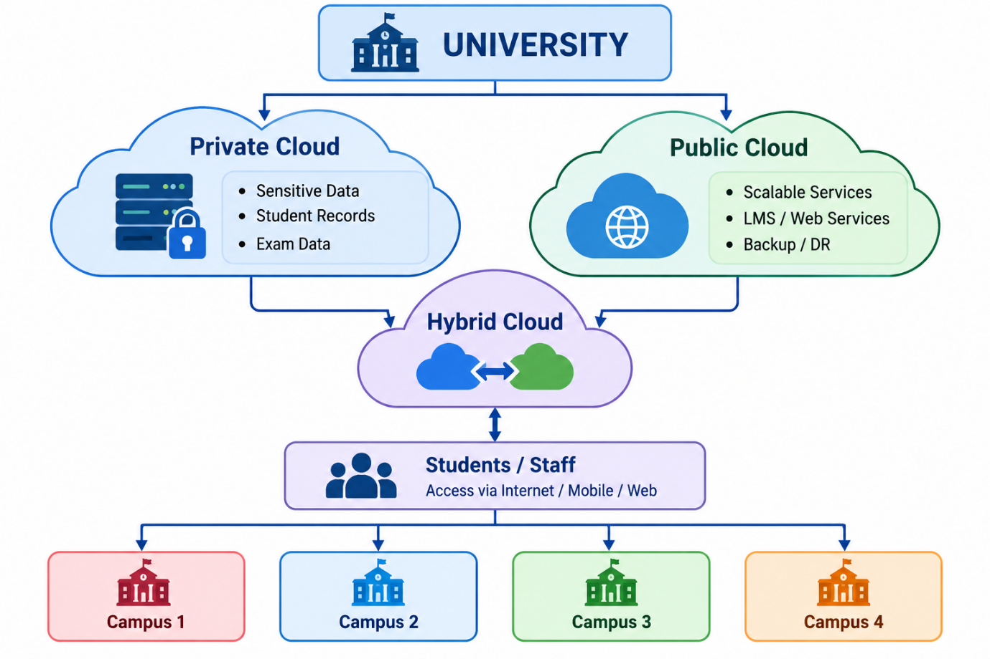
Conclusion
The university should adopt a hybrid cloud model based on virtualization. Cloud characteristics such as resource pooling, rapid elasticity, on-demand self-service and measured service directly address the university's low server utilisation, peak-load problems, high infrastructure cost and slow procurement. The model also provides improved scalability, availability, disaster recovery and manageability while allowing sensitive university data to remain under greater control.

TASK 2 – Trace the Evolution and Hardware Evolution (3 Marks)
1. Evolution of Computing Infrastructure
Cloud computing did not appear suddenly. It evolved through several stages, where each stage solved limitations of the previous computing model.
Computing Evolution Timeline

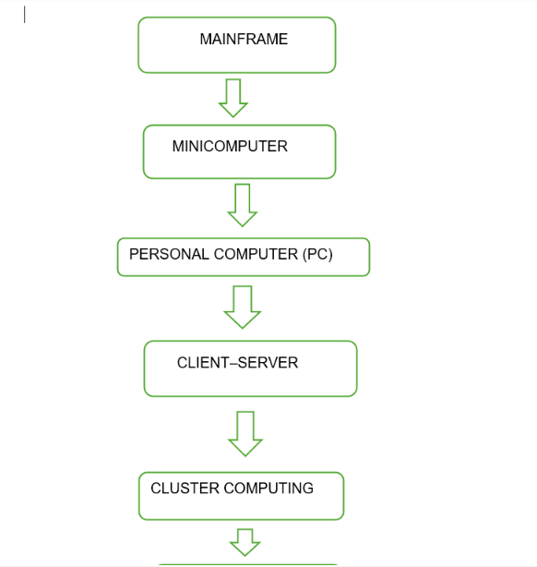

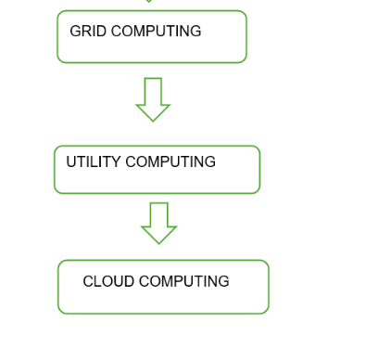
Evolution and Limitations Solved
Stage | Description | Limitation Solved
1. Mainframe | A powerful central computer served many users through terminals. | Provided centralized processing, but was very expensive and had limited flexibility.
2. Minicomputer | Smaller and less expensive computers supported multiple users. | Reduced the cost and size of mainframes.
3.Personal Computer (PC) | Computing power was provided directly to individual users. | Reduced dependency on centralized systems and made computing affordable.
4. Client–Server | Clients requested services from dedicated servers over a network. | Enabled sharing of applications, databases and resources across multiple computers.
5.Cluster Computing | Multiple connected computers worked together as one system. | Improved performance and availability compared with a single server.
6.Grid Computing | Computing resources from different locations were combined to solve large problems. | Allowed distributed resources to be shared across organisations and locations.
7.Utility Computing | Computing resources were provided like a utility and users paid according to usage. | Reduced the need to purchase large amounts of infrastructure in advance.
8.Cloud Computing | Virtualized computing resources are delivered over networks with on-demand provisioning and elasticity. | Provides scalable, flexible and measured computing without requiring users to own all physical infrastructure.

2.2. Hardware Evolution That Enabled Cloud Computing
Several hardware developments made large-scale cloud computing practical.
a) Multi-Core Processors
Processors evolved from single-core to multi-core CPUs.
Impact:
Multiple tasks can run simultaneously, increasing processing capacity and allowing virtualization of several virtual machines on one physical server.
b) Commodity Servers
Powerful but relatively low-cost standard servers became widely available.
Impact:
Cloud providers could build large data centres using thousands of standard servers instead of relying only on expensive specialised machines.
c) High-Capacity Storage
Storage technology developed from small-capacity disks to large HDDs, SSDs and distributed storage systems.
Impact:
Cloud providers can store huge amounts of student records, documents, examination data, backups and application data.
d) High-Speed Networking
Network technologies evolved from slower local networks to high-speed Ethernet, fibre-optic and advanced Internet networks.
Impact:
Users can access cloud applications and data quickly from different campuses and locations.
e) Modern Data Centres
Large data centres introduced redundant power, cooling, networking, security and multiple servers.
Impact:
They provide high availability, scalability and disaster recovery for cloud services.

2.3. Hardware Evolution Supporting Cloud
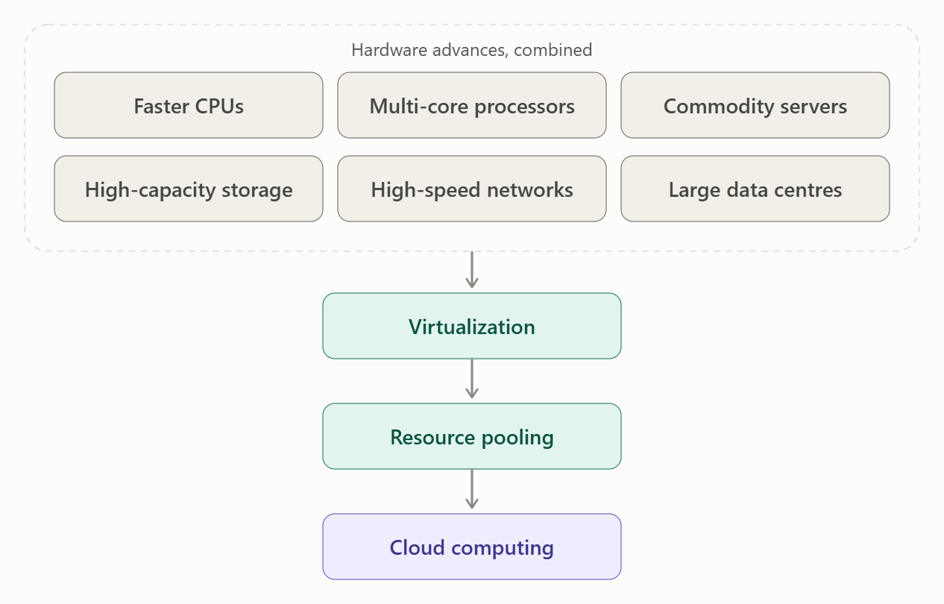How Hardware Solved Earlier Limitations
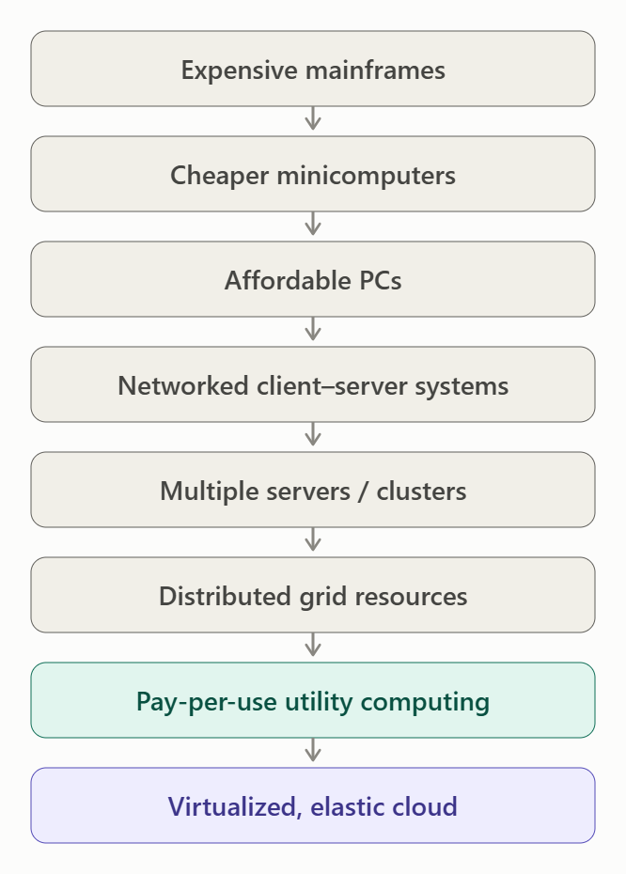
2.4. Current System of the University
The university's current infrastructure corresponds mainly to the traditional dedicated-server / client–server stage, rather than a cloud environment.
Reasons:
- The university has 12 physical servers.
- Each application has its own dedicated server.
- Average CPU utilisation is only 15%, showing poor resource utilisation.
- During admissions and exams, utilisation can exceed 95%.
- New physical servers require 6–8 weeks to procure.
- There is no disaster-recovery site.
- The applications are mainly large monolithic programs.
Therefore, the university is using a traditional on-premise client–server infrastructure with dedicated physical servers.

2.5. Conclusion
The evolution from mainframes → minicomputers → PCs → client–server → clusters → grid → utility computing → cloud progressively improved cost, resource sharing, scalability and availability. At the same time, multi-core CPUs, commodity servers, high-capacity storage, high-speed networks and modern data centres provided the hardware foundation required for virtualization and cloud computing.
Hence, the university should move from its current dedicated physical-server environment toward a virtualized hybrid-cloud infrastructure.

TASK 3 – Analyse Internet Software Evolution (3 Marks)
3.1. Evolution of Internet Software
Internet software has evolved from simple static pages to highly interactive and cloud-based applications. Each stage improved accessibility, interaction, integration and scalability.
Evolution Timeline
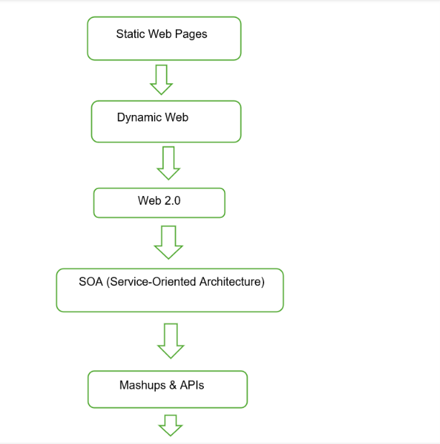

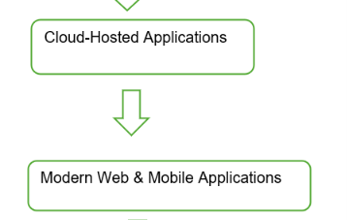
Software Evolution and Improvements
Stage | Main Features | Limitation Solved
1. Static Web (Web 1.0) | Fixed HTML pages; mainly read-only information. | Provided basic information through the Internet but had little user interaction.
2. Dynamic Web | Server-side programs generate pages based on user requests and database information. | Allowed personalised and database-driven services.
3. Web 2.0 | Interactive websites, user-generated content and rich interfaces. | Improved user interaction and collaboration.
4. SOA | Applications are divided into reusable services that communicate through networks. | Reduced dependency on large monolithic applications and improved reusability.
5. Mashups and APIs | Data and functions from different applications are combined through APIs. | Made application integration easier.
6. Cloud-Hosted Applications | Applications and data are hosted on cloud infrastructure and accessed through the Internet. | Provides scalability, elasticity, availability and access from multiple locations.

3.2. Role of Internet Technologies
Browser
A web browser provides the user interface for accessing cloud applications.
University example: Students can access the Student Information System and LMS using Chrome, Edge or another browser without installing the complete application locally.
HTTP/HTTPS
HTTP/HTTPS provides communication between the client and web server.
- HTTP transfers requests and responses.
- HTTPS adds encryption and secure communication.
- It is important for protecting student and payment information.
AJAX
AJAX (Asynchronous JavaScript and XML) allows web pages to communicate with the server without completely reloading the page.
University example: A student can check course availability or examination results and update only the required part of the page.
APIs
APIs (Application Programming Interfaces) allow different applications to communicate with each other.
For the university, APIs can connect:
Mobile App
↓
REST API
↓
University Applications
↓
Student Database
APIs will become particularly important when the university opens services to 40 affiliated colleges.

3.3. Comparison of Software Models
Feature | Desktop Software | Client–Server Software | Web/Cloud-Delivered Software
Installation | Installed on individual computers | Client software may be required | Usually accessed through browser/app
Access | Mainly one device | Network-based | Internet/network-based
Updates | Manually on each system | Managed on server and clients | Centralised updates
Scalability | Limited | Moderate | High
Maintenance | High on individual devices | Server and client maintenance | Mainly central/cloud management
Remote Access | Limited | Requires network/VPN | Easy access through Internet
Example | Desktop library application | University client-server SIS | Cloud-based LMS/mobile application

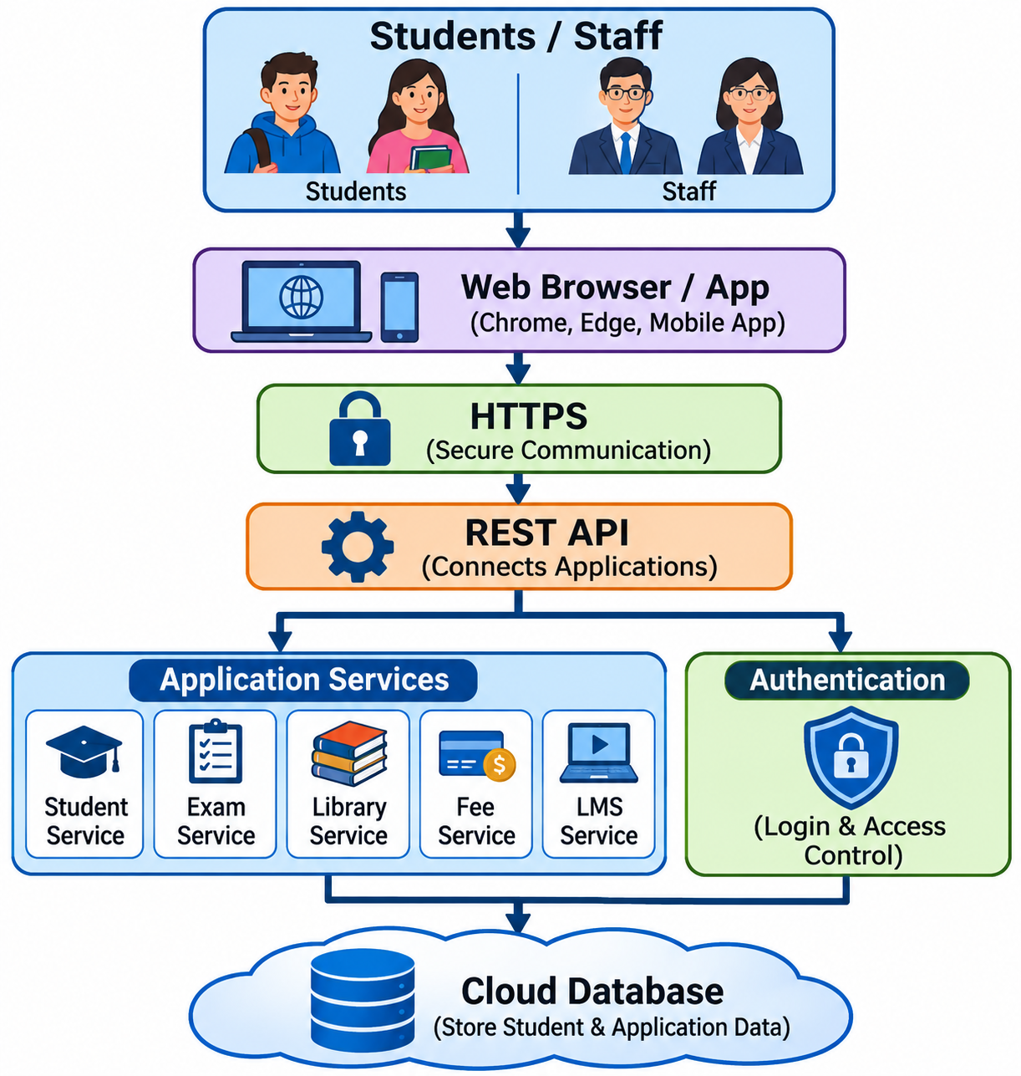
3.4. Effect on University Application Design
The university currently has large monolithic applications with no public interfaces. Internet software evolution suggests moving toward web-based, service-oriented and API-enabled applications.
Proposed Design

Application Design Changes
- Convert monolithic applications into services where practical.
- Provide REST APIs for mobile applications and affiliated colleges.
- Use HTTPS to protect student and financial information.
- Design applications to be stateless and scalable, allowing multiple application instances to run in the cloud.
- Use web and mobile interfaces so students and staff can access services from all 4 campuses.
- Use APIs to integrate the university's systems with 40 affiliated colleges.
- Use cloud-hosted services so resources can automatically increase during admissions, examinations and result publication.

3.5. Conclusion
Internet software evolved from static web pages to dynamic web applications, Web 2.0, SOA, APIs and cloud-hosted applications. Technologies such as browsers, HTTPS, AJAX and APIs made it possible to deliver interactive software over networks.
For the university, this evolution supports a transition from isolated monolithic applications to web-based, API-enabled and cloud-scalable services. This will improve accessibility, integration, scalability, maintainability and support for the new mobile app and 40 affiliated colleges.

TASK 4 – Apply Server Virtualization (5 Marks)
4.1. Server Virtualization for the University
Server virtualization is the process of using a hypervisor to divide one physical server into multiple Virtual Machines (VMs). Each VM behaves like an independent computer with its own operating system, CPU, memory, storage and applications.
For the university, virtualization can consolidate the existing 12 physical servers into a smaller number of physical hosts, improving resource utilisation and reducing hardware and maintenance costs.
Basic Virtualization Architecture
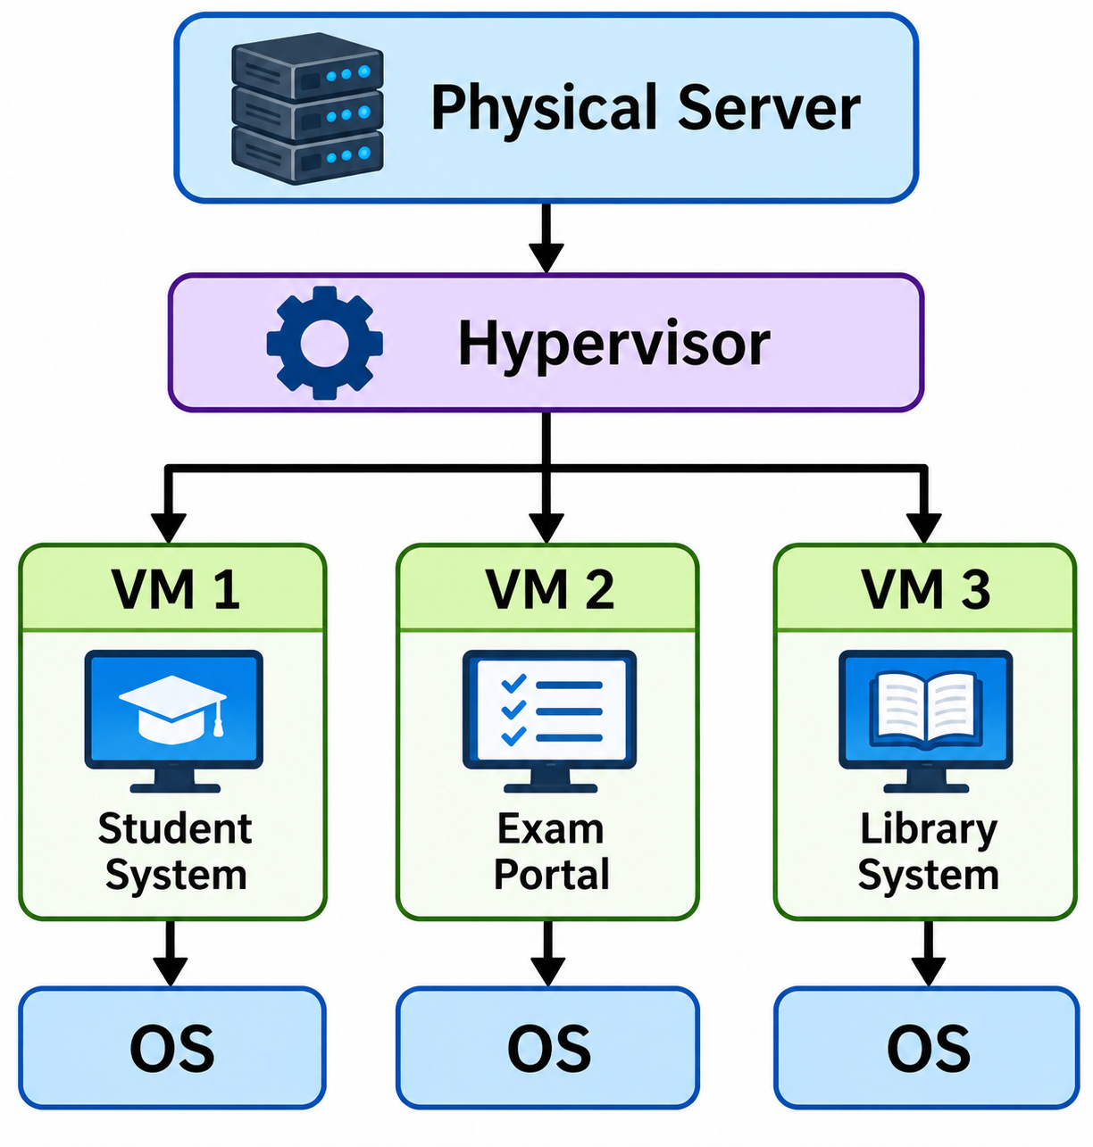

4.2. How a Hypervisor Works
A hypervisor is software that creates and manages virtual machines.
It allocates the physical server's:
- CPU
- RAM
- Storage
- Network resources
among multiple VMs.
Each VM receives virtual hardware and can run its own operating system independently.
Types of Hypervisors
Feature | Type-1 Hypervisor | Type-2 Hypervisor
Also called | Bare-metal hypervisor | Hosted hypervisor
Runs on | Directly on physical hardware | On top of a host operating system
Performance | Higher | Lower due to extra OS layer
Typical use | Data centres and cloud | Personal computers/testing
Examples | VMware ESXi, Microsoft Hyper-V, Xen | VirtualBox, VMware Workstation
University suitability | Highly suitable | Mainly suitable for testing/development
Recommendation: The university should use a Type-1 hypervisor because it provides better performance, isolation and management for production workloads.

4.3. Types of Virtualization
Type | Explanation | Advantage | Limitation
Full Virtualization | VM receives completely virtual hardware and the guest OS does not need modification. | Good compatibility; existing operating systems can run unchanged. | Some virtualization overhead may occur.
Para-Virtualization | Guest OS is modified to communicate efficiently with the hypervisor. | Lower overhead and better performance in some cases. | Requires a compatible/modified guest OS.
OS-Level Virtualization (Containers) | Multiple isolated applications share the same host OS kernel. | Lightweight, fast startup and high application density. | Less isolation than separate VMs; applications must be compatible with the host OS.
Hardware-Assisted Virtualization | CPU hardware features such as Intel VT-x/AMD-V assist the hypervisor. | Improves VM performance and reduces virtualization overhead. | Requires compatible hardware.
Recommended Approach
Use hardware-assisted Type-1 virtualization for the main university infrastructure and containers for suitable modern application components.

4.4. Applications: VMs vs Containers
The university has applications such as:
- Student Information System
- Learning Management System
- Library System
- Exam Portal
- Email
- Database services
Applications Suitable for VMs
Student Information System, Exam Portal, Library System and Database servers should initially run in VMs.
Reasons:
- Existing applications are large monolithic applications.
- They may require different operating-system configurations.
- VMs provide stronger isolation.
- Existing applications can be migrated without major code changes.
- Snapshots and backup are easier to manage.
Applications Suitable for Containers
New or redesigned components such as:
- REST APIs
- Mobile-app backend
- Authentication service
- Fee-payment service
- Notification service
- Small web services
can run in containers.
Reasons:
- Containers start quickly.
- They require fewer resources than VMs.
- They are easy to scale horizontally.
- They are suitable for modern API-based applications.
- Multiple instances can be created during peak demand.
Proposed Arrangement
Physical Hosts
│
Type-1 Hypervisor
│
┌─────────────┼─────────────┐
↓ ↓ ↓
VM VM VM
Student Exam Database
System Portal
│
└───────────┐
↓
Container Platform
│
┌───────────┼────────────┐
↓ ↓ ↓
REST API Fee Service Mobile Backend

4.5. Consolidation Calculation
The university currently has:
- 12 physical servers
- Average CPU utilisation = 15% per server
- Target host utilisation = 70%
We assume:
- The workloads can be consolidated effectively.
- CPU is the limiting resource.
- The 15% average utilisation represents the average workload that must be carried after consolidation.
- We keep the host utilisation at or below 70% to leave capacity for workload variation and peaks.
Step 1: Calculate total current CPU load
Each server uses approximately:
$$15\%=0.15$$
For 12 servers:
$$12×0.15=1.8$$
So, the total workload is equivalent to 1.8 fully utilised servers.
Step 2: Calculate required physical hosts
Each new physical host should be used up to 70%:
$$\text{Number of hosts}=\frac{\text{Total workload}}{\text{Target utilisation}} \\ =\frac{1.8}{0.70} \\ =2.57$$
Since we cannot have a fraction of a physical server, round up:
$$\boxed{\text{Required hosts}=3}$$
Step 3: Check the utilisation
With 3 hosts:
$$\frac{1.8}{3}×100=60\%$$
Therefore:
$$\boxed{\text{Average utilisation per host}≈60\%}$$
This is below the 70% target.
Consolidation Result
Before Virtualization

12 Physical Servers
↓
Average utilisation = 15%
↓
Large amount of unused capacity

After Virtualization

3 Physical Hosts
↓
Multiple VMs per host
↓
Average utilisation ≈ 60%
↓
Better resource utilisation
Important Practical Recommendation
3 hosts is the theoretical minimum based on the given average CPU utilisation. For production, I would recommend at least 4 physical hosts if the budget permits, because this provides additional capacity and better resilience if one host fails.
Thus:
- Calculated requirement: 3 hosts
- Recommended production design: 4 hosts for better availability/failover
Also, the 15% average cannot be used to guarantee performance during admissions/exams, because the scenario says peaks exceed 95%. The design therefore needs elasticity, monitoring and sufficient reserved capacity.
4.6. Benefits of Virtualization
a) Live Migration
A running VM can be moved from one physical host to another with very little interruption.
Benefit: Maintenance can be performed without significantly affecting university services.
b) Snapshots
A snapshot captures the state of a VM at a particular point in time.
Benefit: Useful before software updates or configuration changes and can assist with recovery.
c) Resource Over-Commitment
The hypervisor can allocate virtual CPU or memory based on expected usage, allowing resources to be shared efficiently.
Benefit: Improves resource utilisation when VMs do not use their maximum allocated resources simultaneously.
Caution: Excessive over-commitment can cause performance problems, especially during examinations.
d) Better Utilisation
Instead of 12 physical servers operating at an average of 15%, multiple workloads can share fewer physical hosts.
e) Faster Provisioning
New VMs can be created much faster than purchasing and installing physical servers.
f) Cost Reduction
Fewer physical servers reduce hardware, power, cooling and maintenance costs.
4.7. Risks of Virtualization
Risk | Explanation | Mitigation
Noisy Neighbour | One VM may consume excessive CPU, memory or network resources and affect other VMs. | Resource limits, reservations and monitoring.
Hypervisor Failure | Failure of a physical host/hypervisor can affect multiple VMs simultaneously. | Use multiple hosts, clustering and automatic failover.
Security Isolation | A vulnerability in the hypervisor or VM configuration could affect isolation. | Patch hypervisors, use network segmentation and strong access controls.
Over-Commitment | Too many virtual resources may be allocated compared with available physical resources. | Maintain capacity reserves and monitor utilisation.
Single Host Dependency | Several applications may depend on one physical host. | Distribute critical VMs across different hosts.

8. Final Virtualization Plan
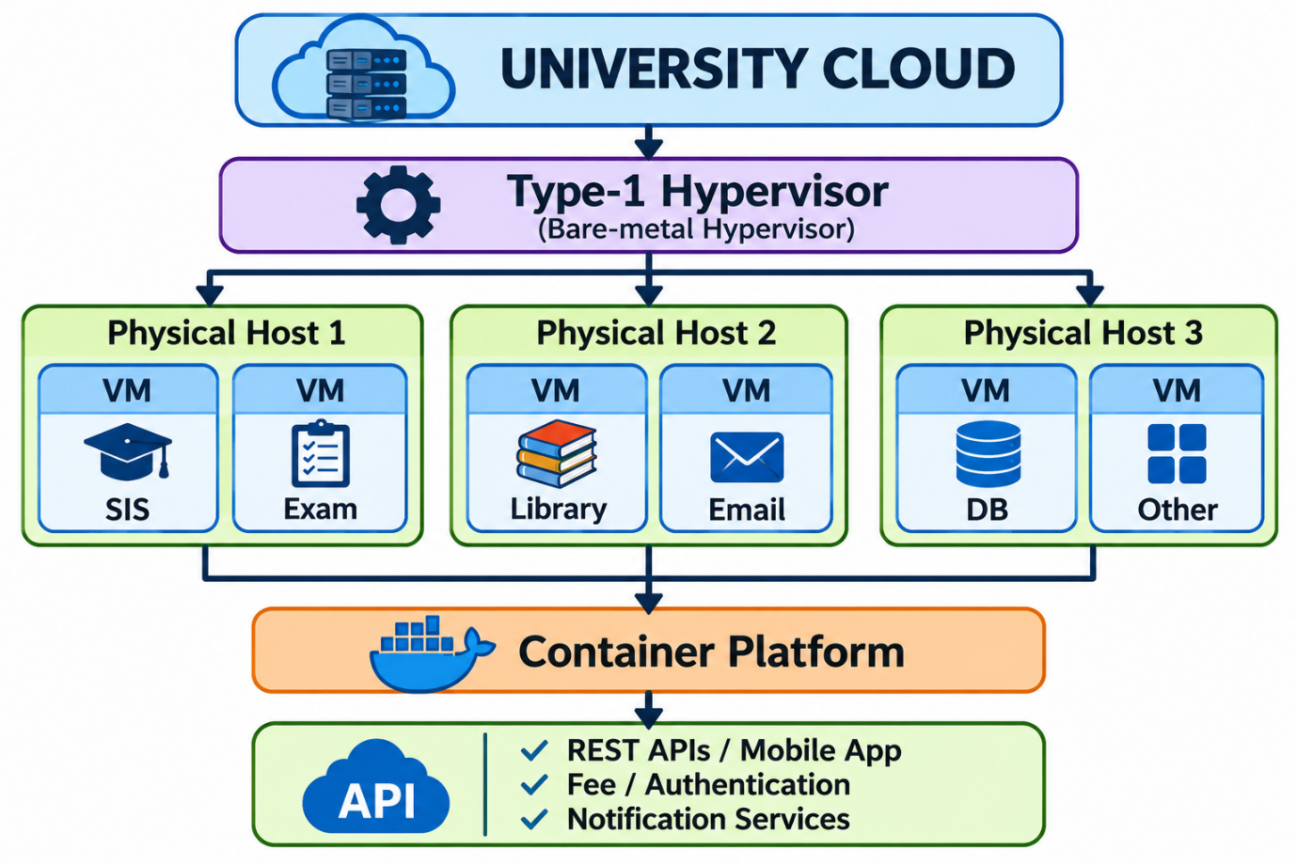
Conclusion
Server virtualization can reduce the university's 12 physical servers to a calculated minimum of 3 hosts, based on the given 15% average utilisation and 70% target utilisation. However, 4 hosts are preferable for production to provide better fault tolerance and availability. Existing monolithic systems should initially run in VMs, while new API-based and mobile services can use lightweight containers. Live migration, snapshots and controlled resource sharing improve manageability, while risks such as noisy neighbours, hypervisor failure and security isolation must be addressed through monitoring, redundancy and proper security controls.

TASK 5 – Apply Web Services (4 Marks)
5.1. Overview of Web Services
Web services are software components that allow different applications to communicate and exchange data over a network using standard protocols and data formats.
For the university, web services can connect the Student Information System, Exam Portal, Library System, Fee System, mobile application and affiliated colleges.
Web services support Service-Oriented Architecture (SOA) because university functions can be provided as independent, reusable services.
Basic Architecture
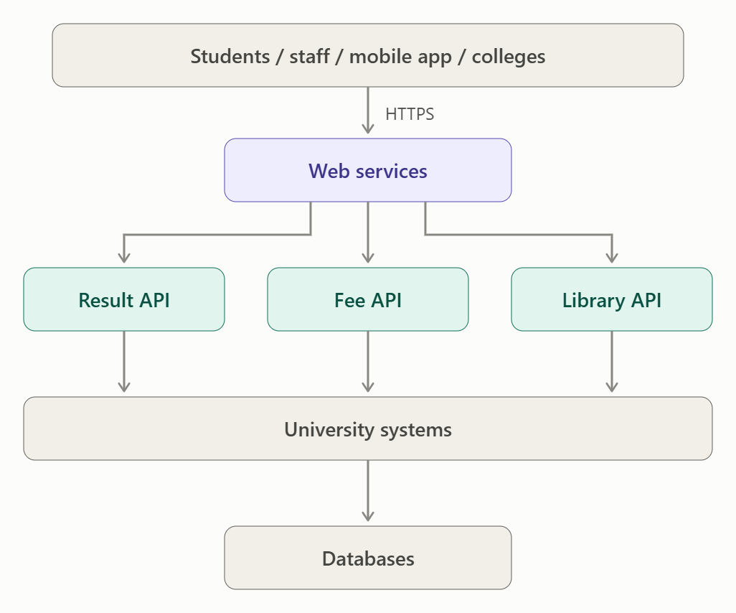
5.2. SOAP, WSDL, UDDI and REST Comparison
Feature | SOAP | WSDL | UDDI | REST
Full form | Simple Object Access Protocol | Web Services Description Language | Universal Description, Discovery and Integration | Representational State Transfer
Purpose | Communication protocol | Describes a web service | Service discovery/registry | Architectural style for web services
Data format | Mainly XML | XML | XML | Usually JSON; can also use XML
Transport | HTTP/HTTPS and other protocols | Describes service endpoints/bindings | Usually associated with SOAP-based service discovery | Mainly HTTP/HTTPS
Operations | Defined through SOAP messages | Defines operations and messages | Helps publish/find services | Uses HTTP methods
Complexity | Higher | Service description | Registry-based | Simpler
Best suited for | Enterprise/legacy systems requiring strict contracts | Describing SOAP services | Discovering registered services | Mobile, web and cloud APIs
REST HTTP Methods
HTTP Method | Purpose | University Example
GET | Retrieve data | Get examination result
POST | Create/process data | Make a fee-payment request
PUT | Update existing data | Update student information
DELETE | Remove data | Delete a permitted resource
JSON Example
{
"studentId": "STU1001",
"semester": 6
}
JSON is generally preferred for modern REST APIs because it is lightweight and easy for web and mobile applications to process.

5.3. University Functions as Web Services
The following services can be exposed to the university's mobile application and 40 affiliated colleges.

Service 1 – Result Lookup Service
Purpose
Allows students or authorised colleges to retrieve examination results.
Endpoint:
GET /api/v1/students/STU1001/results?semester=6
Method: GET
Sample Request
GET /api/v1/students/STU1001/results?semester=6
Authorization: Bearer <token>
Sample Response
{
"studentId": "STU1001",
"semester": 6,
"results": [
{
"subject": "Cloud Computing",
"grade": "A"
},
{
"subject": "Network Security",
"grade": "B+"
}
]
}
Choice: REST
REST is suitable because result lookup is mainly a read operation. It is lightweight, fast and easy to consume from browsers, mobile applications and affiliated-college systems.

5.4. Service 2 – Fee Payment Service
Purpose
Allows authorised users to initiate and check university fee payments.
Endpoint:
POST /api/v1/payments
Method: POST
Sample Request
{
"studentId": "STU1001",
"amount": 25000,
"feeType": "Semester Fee",
"paymentReference": "PAY12345"
}
Sample Response
{
"paymentId": "P10025",
"studentId": "STU1001",
"status": "SUCCESS",
"amount": 25000
}
Choice: REST for the new cloud system
REST is suitable for the university's mobile app and affiliated colleges because it works naturally with HTTPS and JSON and is lightweight for high-volume requests.
However, if the university's existing payment gateway requires SOAP-based integration, a SOAP service can be retained at the integration boundary.

5.5. Service 3 – Library Search Service
Purpose
Allows students and staff to search for books and library resources.
Endpoint:
GET /api/v1/library/books?title=cloud
Method: GET
Sample Request
GET /api/v1/library/books?title=cloud
Authorization: Bearer <token>
Sample Response
{
"books": [
{
"bookId": "B101",
"title": "Cloud Computing",
"author": "Thomas Erl",
"available": true
},
{
"bookId": "B205",
"title": "Cloud Architecture",
"author": "Michael J. Kavis",
"available": false
}
]
}
Choice: REST
REST is suitable because library search is a simple query/retrieval operation and can be easily integrated into both the university website and mobile application.

5.6. Optional Service – Student Information Service
The university can also expose student information to authorised affiliated colleges.
Endpoint:
GET /api/v1/students/STU1001
Method: GET
Sample Response
{
"studentId": "STU1001",
"name": "Student Name",
"program": "B.Tech",
"semester": 6,
"campus": "Campus 1"
}
Choice: REST, because it is lightweight and suitable for mobile and web applications.

5.7. SOAP Example
For an existing legacy application that requires SOAP, the university can expose a SOAP service.
SOAP Request
<soap:Envelope>
<soap:Body>
<GetStudentResult>
<StudentId>STU1001</StudentId>
<Semester>6</Semester>
</GetStudentResult>
</soap:Body>
</soap:Envelope>
SOAP Response
<soap:Envelope>
<soap:Body>
<GetStudentResultResponse>
<StudentId>STU1001</StudentId>
<Grade>A</Grade>
</GetStudentResultResponse>
</soap:Body>
</soap:Envelope>
SOAP is useful when:
- The university has existing legacy SOAP systems.
- A strict service contract is required.
- Enterprise systems require established SOAP-based integration.

5.8. Recommended Web-Service Architecture
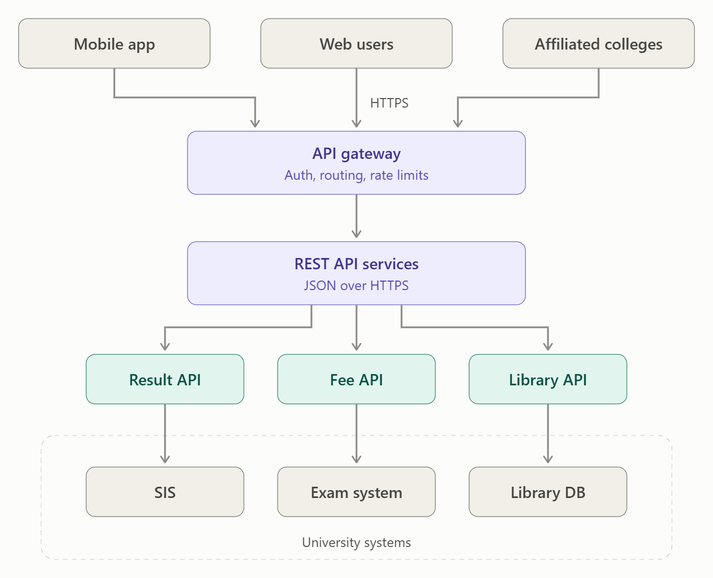
Final Recommendation
For the university's new cloud environment, REST should be the primary web-service approach because it is lightweight, scalable and well suited to the planned mobile application and 40 affiliated colleges. JSON over HTTPS should be used for most new services.
SOAP should be retained where existing legacy systems or external enterprise integrations require it. WSDL can describe SOAP services, while UDDI can provide service discovery in environments that use a registry.
Therefore, the university can use a hybrid web-service strategy: REST for new cloud/mobile services and SOAP for necessary legacy integrations. This provides good scalability, interoperability, maintainability and compatibility.

TASK 6 – Analyse the Service Models: IaaS, PaaS and SaaS (5 Marks)
6.1. Introduction
Cloud service models define how much of the computing environment is managed by the cloud provider and how much is managed by the university.
The three main models are:
- IaaS – Infrastructure as a Service
- PaaS – Platform as a Service
- SaaS – Software as a Service
For the university, these models can be combined rather than using only one model.

6.2. Definition of IaaS, PaaS and SaaS
IaaS – Infrastructure as a Service
IaaS provides virtualised servers, storage, networking and other infrastructure.
The cloud provider manages the physical infrastructure, while the university manages the operating system, applications and data.
Example provider: Amazon Web Services (AWS EC2)
University example: Run the existing SIS or Exam Portal as virtual machines.

PaaS – Platform as a Service
PaaS provides a ready-to-use platform containing the operating system, runtime environment, middleware and development tools.
The university mainly manages its application code and data, while the provider manages the underlying infrastructure and platform.
Example provider: Microsoft Azure App Service
University example: Deploy new REST APIs, mobile-app backend and fee services without managing servers.

SaaS – Software as a Service
SaaS provides a complete software application over the Internet.
The provider manages almost everything, including infrastructure, operating system, application platform and application software.
Example provider: Google Google Workspace for university email.
University example: Use a managed cloud email service instead of maintaining an email server.

6.3.Layer-Wise Responsibility
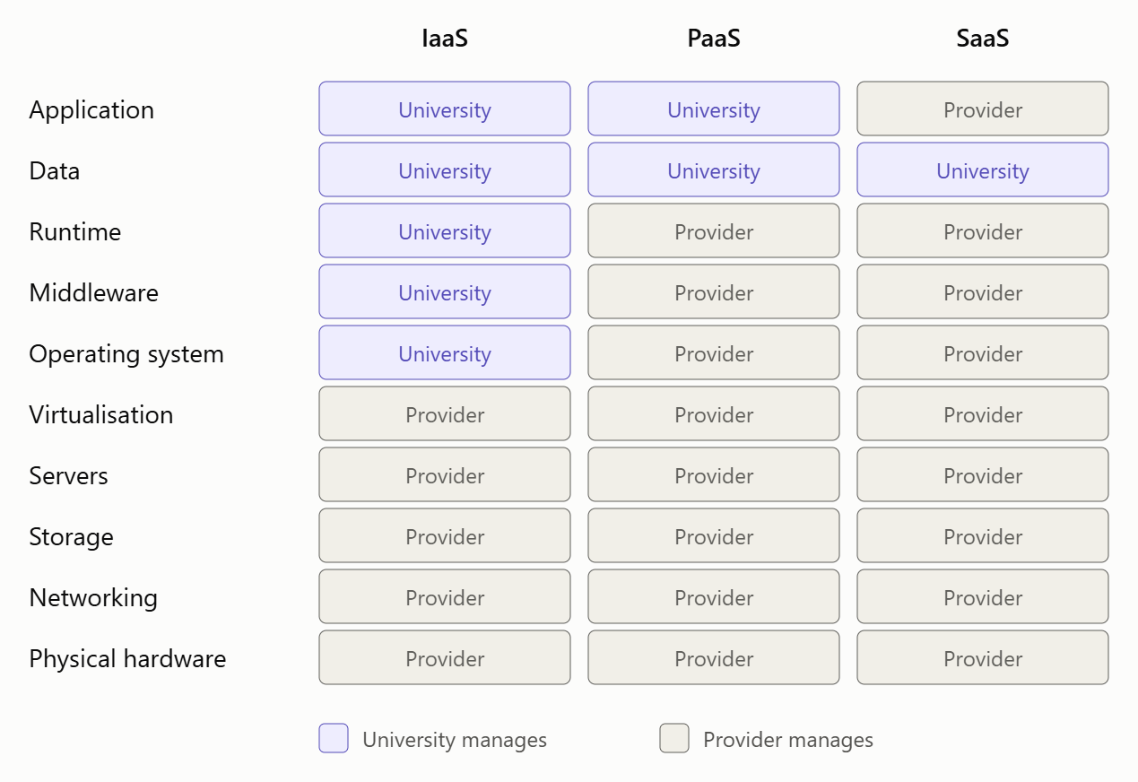
Simple View
IaaS
University manages more
↓
Applications
Data
OS
Runtime
↓
Provider manages
Virtualization → Servers → Storage → Network → Hardware

PaaS
University manages
Applications
Data
↓
Provider manages
Runtime → OS → Virtualization → Servers → Storage → Network → Hardware

SaaS
Provider manages almost everything
↓
Application → Runtime → OS → Infrastructure → Hardware

6.4. Categorisation of the Five University Applications
University Application | Recommended Model | Reason
Student Information System (SIS) | IaaS | Existing SIS is a large monolithic application. IaaS allows the university to migrate it to VMs with minimal application changes and retain control of the OS and application.
Learning Management System (LMS) | PaaS | The LMS can be modernised and deployed on a managed application platform, reducing server and OS maintenance while allowing the university to control its application and data.
Library System | IaaS | If the existing library application is a legacy/monolithic system, moving it to a VM provides compatibility without requiring major redevelopment.
Exam Portal | PaaS | The exam portal experiences large temporary traffic peaks. PaaS can automatically scale application instances and reduces infrastructure management.
Email | SaaS | Email is a standard service that does not provide much benefit from university-managed infrastructure. A managed email service eliminates server maintenance and provides high availability.
Note: These are recommended deployment models for the university's migration. In practice, the exact choice can change depending on whether a suitable managed SaaS/PaaS version of an application is available.

6.5. Reasoning Behind Each Decision
6.5.1. Student Information System – IaaS
The SIS is currently a large monolithic application running on a dedicated physical server.
Moving it directly to IaaS allows the university to:
- Create a VM for the SIS.
- Keep its existing operating system.
- Avoid major code changes initially.
- Increase CPU/RAM when admission demand increases.
- Take VM snapshots and backups.
- Gradually modernise the application later.
Therefore, IaaS is appropriate for the initial SIS migration.

6.5.2. LMS – PaaS
The LMS needs to support students across all four campuses and may experience increased usage during assignments and examinations.
PaaS can provide:
- Managed runtime environment.
- Automatic scaling.
- Reduced OS and server maintenance.
- Easy deployment of updated application versions.
- Integration with REST APIs.
Therefore, PaaS is suitable when the LMS is compatible with a managed application platform.

6.5.3. Library System – IaaS
The existing Library System is also a legacy application.
Using IaaS allows the university to move the existing application into a VM without completely redesigning it.
This reduces migration risk and provides better resource utilisation than maintaining a dedicated physical server.
Therefore, IaaS is a practical migration choice.

6.5.4. Exam Portal – PaaS
The Exam Portal has highly variable demand. During examination periods, thousands of students may access it simultaneously.
PaaS is suitable because:
- Application instances can scale horizontally.
- Infrastructure is managed by the provider.
- The university focuses on application functionality.
- It can support high availability.
- It reduces operational workload.
Therefore, PaaS is preferred for the modernised Exam Portal.

6.5.5. Email – SaaS
Email is a standard, mature service and does not need to be developed or managed by the university.
Using SaaS provides:
- No university-managed mail servers.
- Automatic software updates.
- Spam and security management.
- High availability.
- Easy access through web and mobile devices.
- Reduced maintenance.
Therefore, SaaS is the best choice for university email.

6.5.6. Comparison of IaaS, PaaS and SaaS
Factor | IaaS | PaaS | SaaS
Control | High | Medium | Low
Initial cost | Lower than buying physical servers | Generally lower operational effort | Usually subscription-based
Scalability | High, but university manages scaling configuration | Very high and easier | Provider handles scaling
Maintenance effort | High | Medium/Low | Very low
OS management | University | Provider | Provider
Application management | University | University | Provider
Vendor lock-in | Lower/Medium | Medium/High | Higher
Best suited for | Legacy/custom applications | New/custom applications | Standard applications

6.5.7. Overall Recommended Service-Model Strategy
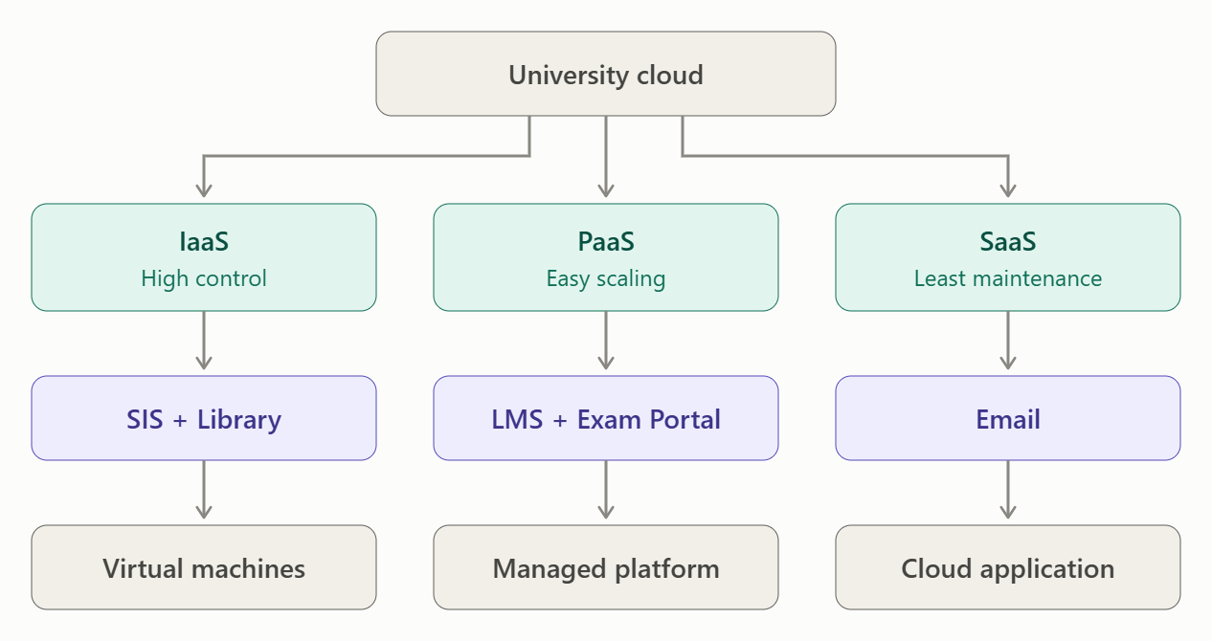
Final Mapping
IaaS → SIS + Library System
Used mainly for legacy applications that need high control and minimal modification.
PaaS → LMS + Exam Portal
Used for applications that need easy deployment, scalability and reduced infrastructure management.
SaaS → Email
Used for a standard service where the university does not need to manage the underlying application or servers.

Conclusion
The university should adopt a mixed service-model strategy rather than forcing every application into one model. IaaS is appropriate for existing monolithic and legacy systems because it provides greater control and easier migration. PaaS is suitable for applications that need modernisation and rapid scaling, particularly the LMS and Exam Portal. SaaS is ideal for standard services such as email because it minimises maintenance.
This combination provides a good balance between control, cost, scalability, manageability and vendor dependency while supporting the university's transition to cloud computing.

TASK 7 – Examine XaaS (Anything-as-a-Service) (3 Marks)
7.1. Introduction to XaaS
XaaS (Anything as a Service) is a cloud computing model in which different IT resources, platforms, software, databases, security functions and infrastructure are delivered as services over a network, usually on a subscription or pay-per-use basis.
Instead of purchasing and maintaining all infrastructure itself, the university can consume required services from cloud providers.
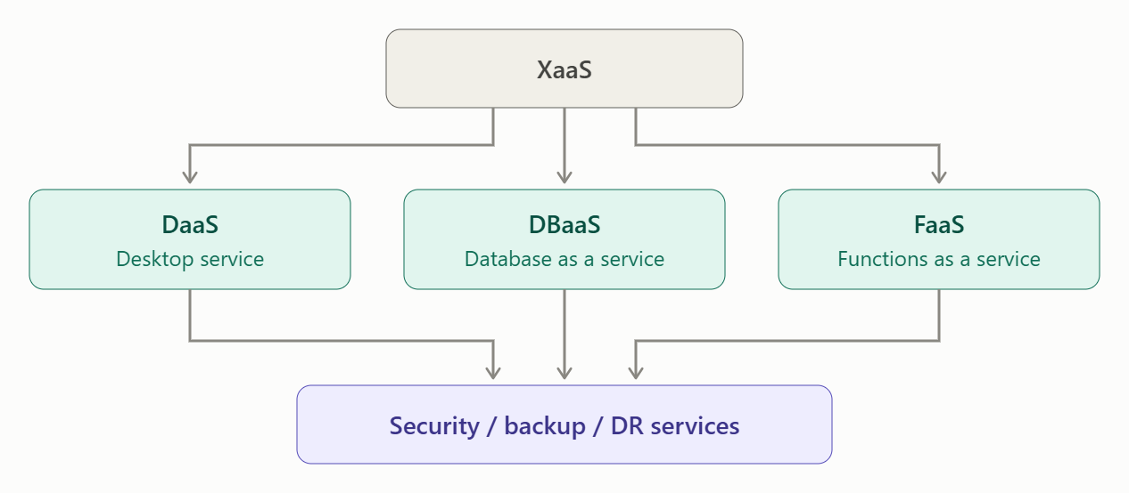
7.2. Major XaaS Variants
XaaS Variant | Meaning | University Use
DaaS – Desktop as a Service | Cloud-hosted virtual desktops delivered to users. | Staff and students can access standard university desktops remotely.
BaaS / MBaaS – Backend/Mobile Backend as a Service | Provides managed backend services for mobile applications. | Supports the university's new mobile app with authentication, databases, notifications and APIs.
FaaS – Function as a Service | Runs small pieces of code only when triggered, without managing servers. | Result notifications, email notifications and small fee-processing tasks can run as functions.
DBaaS – Database as a Service | A cloud provider manages database infrastructure and operations. | Student, library, examination and application databases can use managed cloud databases.
Security-as-a-Service | Security functions such as monitoring, threat detection and identity management are delivered as services. | Protects student records, APIs and applications from security threats.
DRaaS – Disaster Recovery as a Service | Cloud-based disaster recovery and backup infrastructure. | Provides recovery capability because the university currently has no DR site.

7.3. Recommended XaaS Offering 1 – DBaaS
Why DBaaS is suitable
The university manages large amounts of data, including:
- Student records
- Examination results
- Library information
- Fee information
- Staff information
A Database as a Service (DBaaS) provider manages database infrastructure, backups, patching and much of the operational maintenance.
Benefits
- Reduced administration: IT staff do not need to manage database servers manually.
- Scalability: Database capacity can be increased as the number of students and affiliated colleges grows.
- Backup: Automated backups can protect important university data.
- High availability: Managed databases can provide replication and failover.
- Cost efficiency: The university avoids purchasing and maintaining dedicated database hardware.
Justification
DBaaS is highly suitable because the university has 25,000 students and will expose services to 40 affiliated colleges. Database demand and availability requirements will increase significantly, making a managed database valuable.

7.4. Recommended XaaS Offering 2 – DRaaS
Why DRaaS is suitable
The current university infrastructure has no disaster-recovery site. A failure of the existing data centre could make SIS, LMS, Exam Portal, Library and other services unavailable.
Disaster Recovery as a Service (DRaaS) provides cloud-based backup and recovery resources.
Benefits
- Disaster protection: Data and applications can be recovered after a major failure.
- Business continuity: Critical university services can be restored more quickly.
- No separate DR data centre: The university does not need to build another physical facility.
- Scalability: Recovery resources can be increased as university systems grow.
- Improved availability: Supports the university's requirement for reliable services.
Justification
DRaaS is especially important because the university currently has no disaster-recovery site. Failure during admissions, examinations or result publication could have a major impact.

7.5. Why Not Use Too Many XaaS Providers?
Although XaaS reduces infrastructure management, depending on many service providers creates several risks.
1. Vendor Lock-in
Moving data and applications from one provider to another can be difficult if proprietary technologies are used.
2. Integration Complexity
Different providers may use different:
- APIs
- Authentication mechanisms
- Data formats
- Security models
This can make integration difficult.
3. Security and Privacy Risks
Student, examination and financial data may be distributed across multiple providers, increasing the number of systems that must be secured.
4. Availability Dependency
If an important provider experiences an outage, the university's service may become unavailable.
5. Cost Management
Many small subscriptions can become expensive and difficult to monitor.
6. Data Governance
The university must know where its data is stored, who can access it and how it is backed up.

7.6. Recommended XaaS Strategy
UNIVERSITY
│
Hybrid Cloud
│
┌─────────────┼─────────────┐
↓ ↓ ↓
DBaaS DRaaS Other XaaS
│ │
Managed DB Cloud Backup
Student Data Disaster Recovery
│ │
└─────────────┼─────────────┘
↓
University Services
Final Recommendation
The university should prioritise:
1. DBaaS – Database as a Service
For scalable, managed and highly available databases.
2. DRaaS – Disaster Recovery as a Service
To solve the current absence of a disaster-recovery site and improve business continuity.
Other XaaS options such as FaaS, MBaaS, DaaS and Security-as-a-Service can be adopted where they provide clear benefits.
Conclusion
XaaS allows the university to consume technology capabilities as services instead of owning and maintaining everything itself. DBaaS and DRaaS are the two most valuable choices because they directly address the university's growing data requirements and lack of disaster recovery. However, the university should avoid excessive dependence on multiple providers by using standard APIs, strong contracts, data portability, security controls and a clear multi-cloud strategy.

TASK 8 – Design the Cloud Solution Architecture (5 Marks)
8.1. Proposed Cloud Architecture
For the university, I recommend a Hybrid Cloud Architecture combining virtual machines, containers, REST APIs, managed databases, cloud storage and disaster recovery.
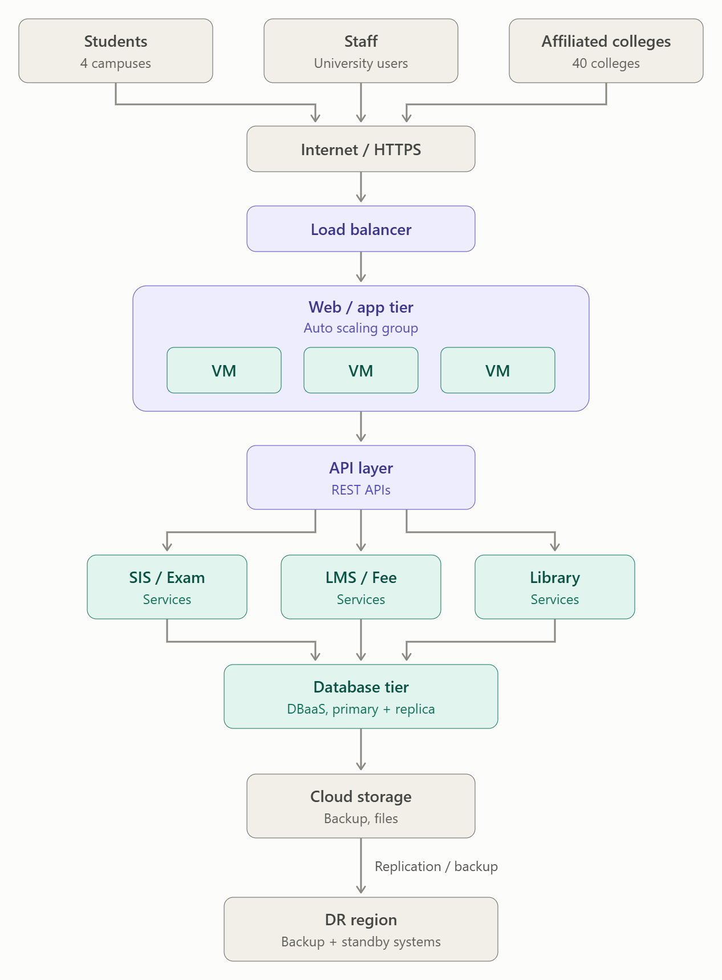
Cloud Architecture Diagram

8.2. Components and Selected Cloud Models
Component | Recommended Model | Deployment | Purpose
Load Balancer | IaaS/XaaS | Public/Hybrid Cloud | Distributes requests among application instances
Web/Application Tier | IaaS | Public Cloud | Runs existing university applications on VMs
REST API Layer | PaaS | Public Cloud | Provides services to mobile apps and affiliated colleges
Containers | PaaS/XaaS | Public Cloud | Runs lightweight API and microservice components
Database Tier | DBaaS/XaaS | Hybrid Cloud | Stores student, exam, fee and library data
Storage | IaaS/XaaS | Hybrid Cloud | Stores documents, backups and application files
Email | SaaS | Public Cloud | Managed university email
DR Region | DRaaS/XaaS | Public Cloud | Disaster recovery and business continuity
Sensitive Data | Private Cloud | Private | Provides additional control over sensitive information

8.3. Deployment Model
Recommended Model: Hybrid Cloud
The university should use a hybrid cloud because it combines the control of a private environment with the scalability of a public cloud.
Private Cloud
Sensitive resources such as:
- Student records
- Examination information
- Important administrative data
can be kept in a controlled private environment.
Public Cloud
Public-cloud resources can be used for:
- Web/application servers
- REST APIs
- Mobile application backend
- Auto-scaling
- Cloud storage
- DR
- Email
This provides scalability without requiring the university to purchase large amounts of physical hardware.

8.4. How Virtualization Is Used
The existing 12 physical servers can be consolidated using Type-1 hypervisors.
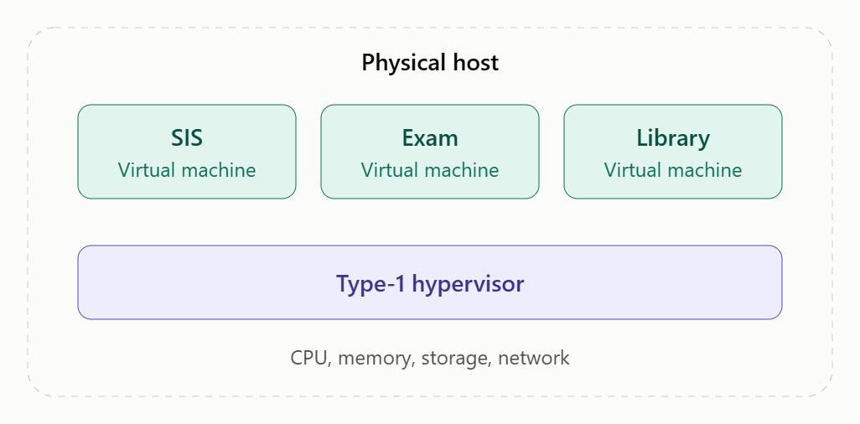
Multiple VMs can run on fewer physical hosts.
For new services, containers can be used for:
- REST APIs
- Mobile backend
- Authentication
- Fee service
- Notification service
This improves resource utilisation and makes scaling easier.

8.5. Load Balancer and Auto-Scaling
The university normally has moderate traffic, but during:
- Admissions
- Online examinations
- Result publication
traffic can increase significantly.
The load balancer distributes incoming requests among multiple application instances.
Normal Period
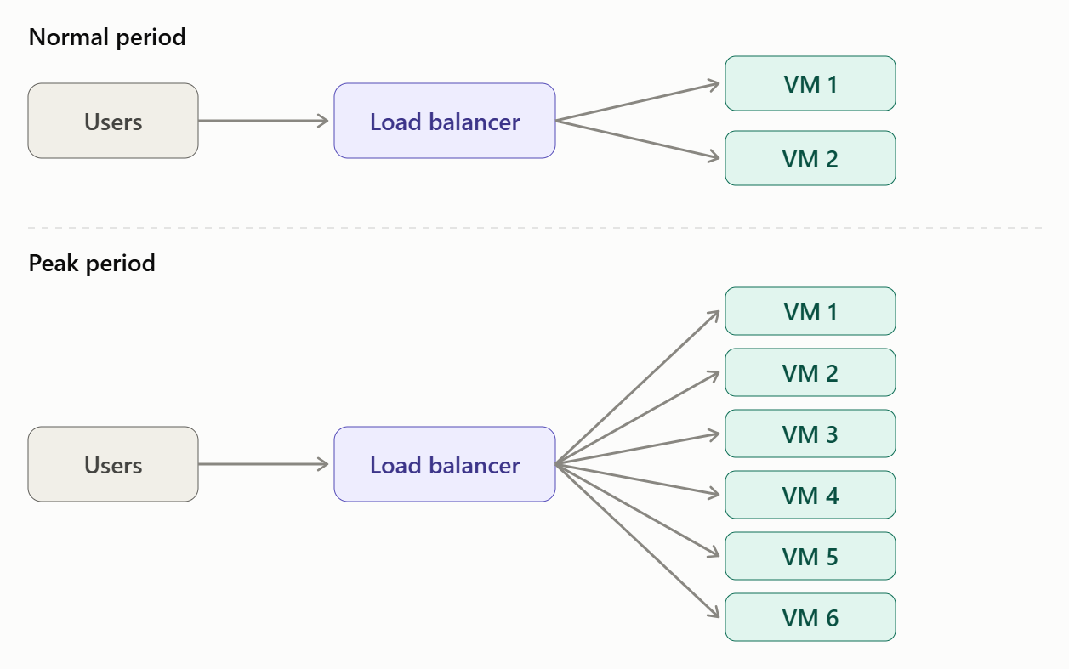When CPU utilisation or request traffic crosses a defined threshold, auto-scaling automatically adds application instances.
When demand decreases, unnecessary instances are removed.
Benefits
- Handles sudden traffic increases.
- Prevents server overload.
- Improves response time.
- Avoids paying for unnecessary capacity during normal periods.
- Supports the university's future mobile application and 40 affiliated colleges.

8.6. API Layer
A dedicated REST API layer should be placed between users/applications and backend services.
Example:
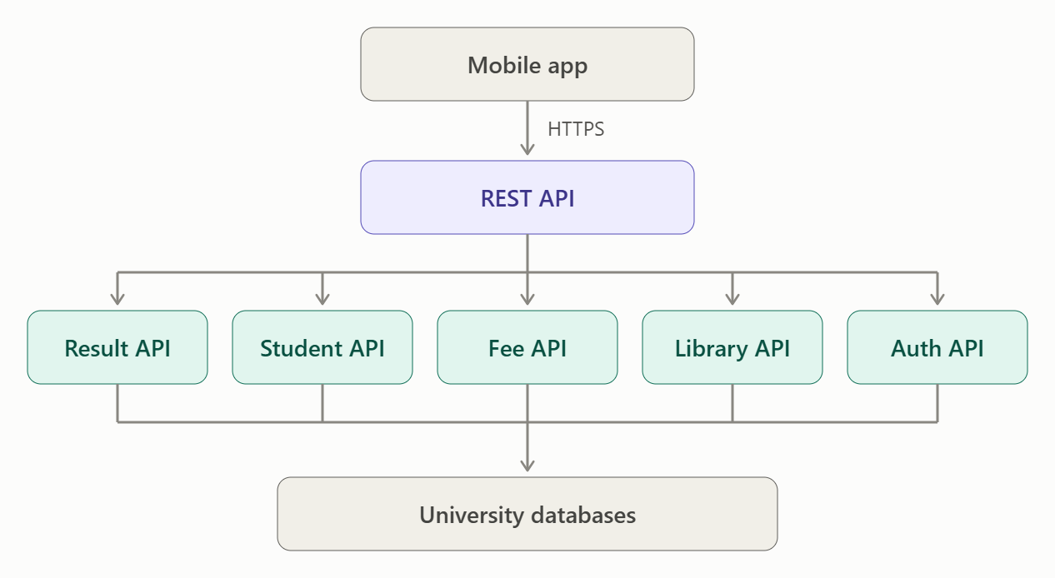Why REST APIs?
- Easy integration with mobile applications.
- Supports web browsers and affiliated colleges.
- Uses standard HTTP methods.
- JSON is lightweight.
- APIs can be independently scaled.
- Reduces direct access to databases.

8.7. Database and Storage Design
Database Tier
A managed DBaaS solution should be used where possible.
The database can have:
- Primary database
- Read replica
- Automated backups
- Encryption
- Failover capability
Storage
Cloud storage can be used for:
- Student documents
- Examination files
- Library documents
- Application files
- Backups
- Logs
This avoids depending entirely on physical storage servers.

8.8. Security Measures
1. Authentication and Access Control
Use:
- Strong authentication
- Role-Based Access Control (RBAC)
- Multi-factor authentication for administrators
- Least-privilege access
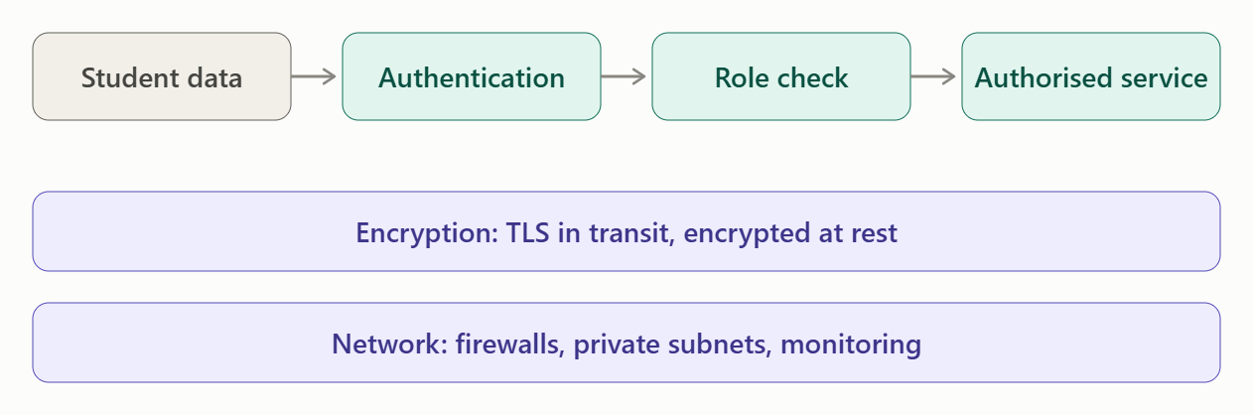
Example:
2. Encryption
Use encryption:
- In transit: HTTPS/TLS
- At rest: Encrypted databases and cloud storage
This is especially important for student, examination and payment information.
3. Network Security
Use:
- Firewalls/security groups
- Network segmentation
- Private database subnets
- API gateway/security controls
- Monitoring and logging

8.9. Availability and Disaster Recovery
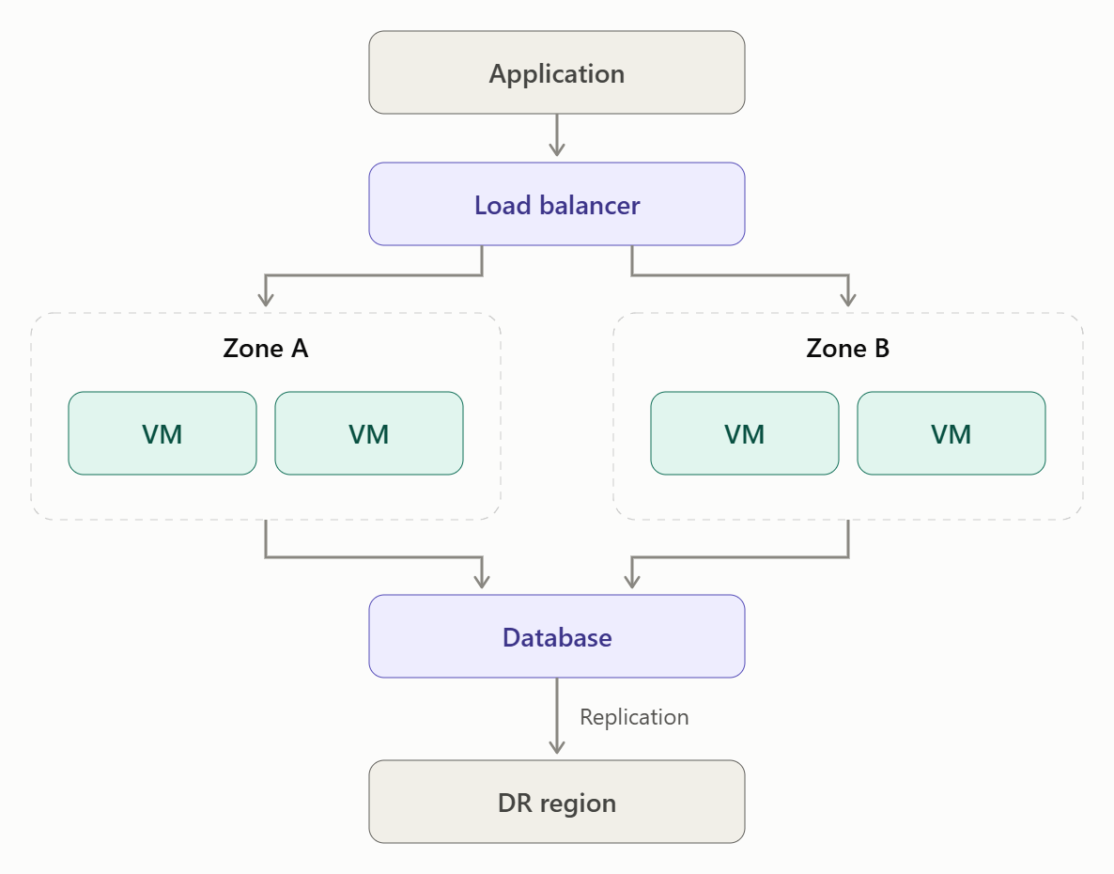
The architecture should use multi-zone deployment.

If one availability zone fails, traffic can be redirected to another zone.
DR Region
The university should maintain backups and replicated critical data in a separate DR region.
This is particularly important because the current system has no disaster-recovery site.

8.10. How the Architecture Handles the Day-4 Challenge
The Day-4 requirement is:
- Mobile application
- Services for 40 affiliated colleges
- Load up to 10× the current peak
- 99.9% availability
- Limited operating budget
The original architecture should therefore be modified rather than completely redesigned.
Required Changes
New Requirement | Architecture Response
Mobile app | REST API + API Gateway
40 affiliated colleges | Secure external API access
10× peak load | Auto-scaling + load balancing
99.9% availability | Multi-zone deployment + redundancy
Limited budget | Pay-as-you-go public cloud + managed services
More users | Horizontally scalable application tier
More database requests | Database replicas/caching
Security | HTTPS, IAM/RBAC, encryption and monitoring
Disaster recovery | DR region + automated backups

8.11. Overall Architecture Decision
Recommended Solution: Hybrid Cloud with Virtualization + PaaS + SaaS + XaaS
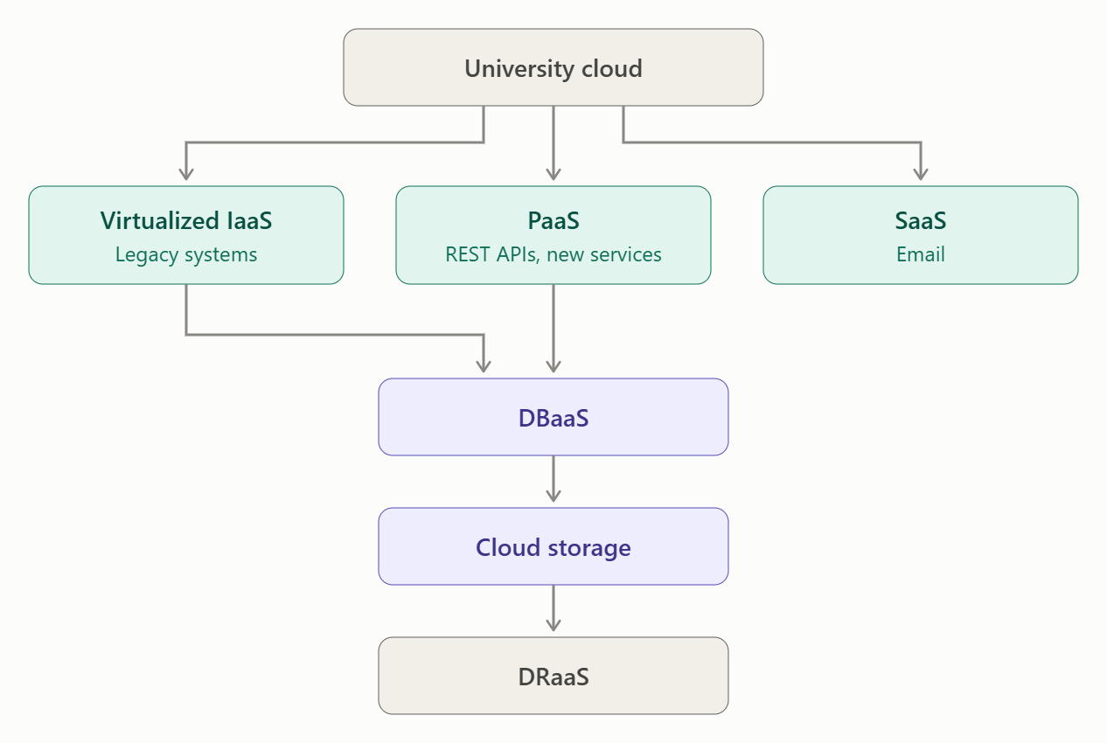
Conclusion
The proposed hybrid cloud architecture combines virtualization, IaaS, PaaS, SaaS and XaaS to provide a balanced solution for the university. Existing monolithic applications can initially run on virtual machines, while new mobile and partner-facing services use REST APIs and PaaS/container platforms. A load balancer and auto-scaling handle admission and examination peaks, while DBaaS, multi-zone deployment, encryption, access control, backups and a separate DR region improve availability and security.
For the Day-4 challenge, the architecture should be modified, not completely redesigned. The existing hybrid-cloud foundation can scale to the expected 10× peak load by adding auto-scaling, API management, database scaling and multi-zone redundancy while keeping costs controlled through pay-as-you-use cloud services.

TASK 9 – Hands-on Implementation and Documentation
9.1. Objective
To implement a small proof-of-concept of the proposed Smart Campus Cloud Architecture by creating a virtual machine and hosting a simple university web service. The service will demonstrate a Student Result Lookup function.

9.2. Tools Used
Tool | Purpose
Oracle VirtualBox | Type-2 virtualization
Ubuntu Linux | Guest operating system
Python | Web service development
Flask | REST API framework
Web Browser / curl | Testing the API

9.3. Proof-of-Concept Architecture
The Ubuntu VM represents a virtual cloud server, while the Flask application represents a university REST service.

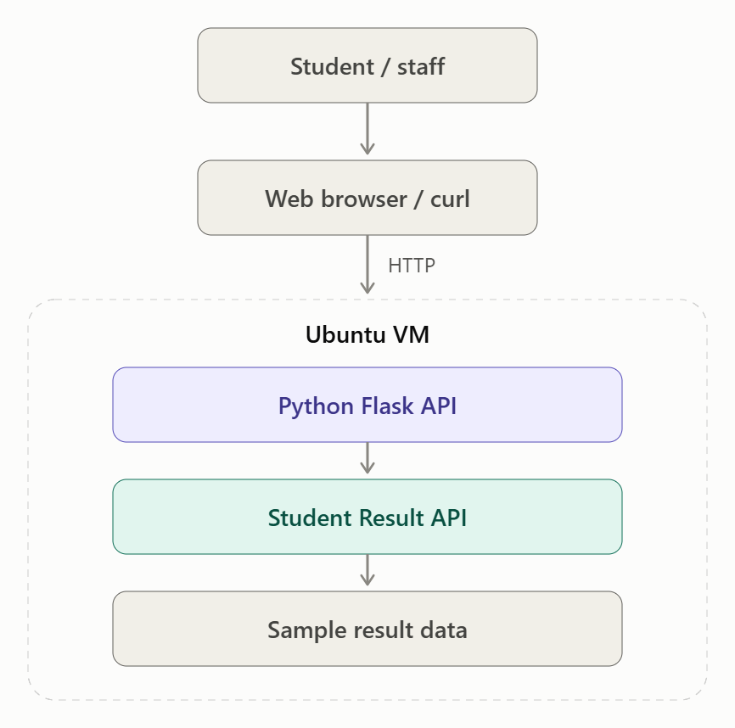
9.4. Step 1 – Create the Virtual Machine
- Open VirtualBox.
- Click New.
- Enter the name:
Smart-Campus-Server
- Select:
  - Type: Linux
  - Version: Ubuntu (64-bit)
- Allocate:
  - CPU: 1 processor
  - RAM: 2 GB
  - Storage: 15 GB
- Attach the Ubuntu ISO file.
- Click Start.
- Install Ubuntu in the VM.
Screenshot Evidence 1
Take a screenshot showing:
- Virtual machine name
- RAM
- CPU
- Storage
Caption:
Figure 1: Configuration of Smart Campus virtual machine.

9.5. Step 2 – Install Python and Flask
Open the Ubuntu Terminal and execute:
sudo apt update
sudo apt install python3 python3-pip -y
pip3 install flask
If Ubuntu does not allow the normal pip3 install, use:
sudo apt install python3-flask -y
Check Flask:
python3 -c "import flask; print(flask.__version__)"
Screenshot Evidence 2
Take a screenshot showing the successful Flask installation.
Caption:
Figure 2: Installation of Python Flask in the Ubuntu virtual machine.

9.6. Step 3 – Create the University REST API
Create a file:
nano app.py
Enter the following code:
from flask import Flask, jsonify

app = Flask(__name__)

@app.route('/')
def home():
return "Smart Campus Cloud Service is Running"

@app.route('/api/result')
def result():
return jsonify({
"student_id": "STU1001",
"name": "Student",
"course": "Cloud Computing",
"semester": 6,
"result": "Pass"
})

app.run(host='0.0.0.0', port=5000)
Save the file.

9.7. Step 4 – Start the Web Service
Run:
python3 app.py
The output will be similar to:
* Running on http://127.0.0.1:5000
* Running on http://192.168.x.x:5000
The Flask server is now running inside the Ubuntu VM.
Screenshot Evidence 3
Take a screenshot of the terminal showing:
Running on http://127.0.0.1:5000
Caption:
Figure 3: Flask REST API successfully running inside the virtual machine.

9.8. Step 5 – Test the Web Page
Open the browser inside Ubuntu and enter:
http://127.0.0.1:5000
Expected output:
Smart Campus Cloud Service is Running
Screenshot Evidence 4
Take a screenshot of the browser displaying the message.
Caption:
Figure 4: Smart Campus web service accessed through the browser.

9.9. Step 6 – Test the Student Result REST API
Open:
http://127.0.0.1:5000/api/result
Expected output:
{
"course": "Cloud Computing",
"name": "Student",
"result": "Pass",
"semester": 6,
"student_id": "STU1001"
}
Screenshot Evidence 5
Take a screenshot showing the JSON response.
Caption:
Figure 5: Student Result REST API response.

9.10. Step 7 – Test Using curl
Open another terminal and execute:
curl http://127.0.0.1:5000/api/result
Expected output:
{"course":"Cloud Computing","name":"Student","result":"Pass","semester":6,"student_id":"STU1001"}
This proves that the REST service can be accessed by a client.
Screenshot Evidence 6
Take a screenshot showing the curl command and JSON response.
Caption:
Figure 6: REST API tested using curl client.

9.11. SaaS/PaaS Component
For this proof-of-concept, Flask acts as the application framework, while the virtual machine provides the server environment.
For the proposed production architecture, the same REST API can be moved to a PaaS platform such as a managed application service. A managed cloud database can also be added as DBaaS instead of storing result data directly in the program.
Proposed Production Flow
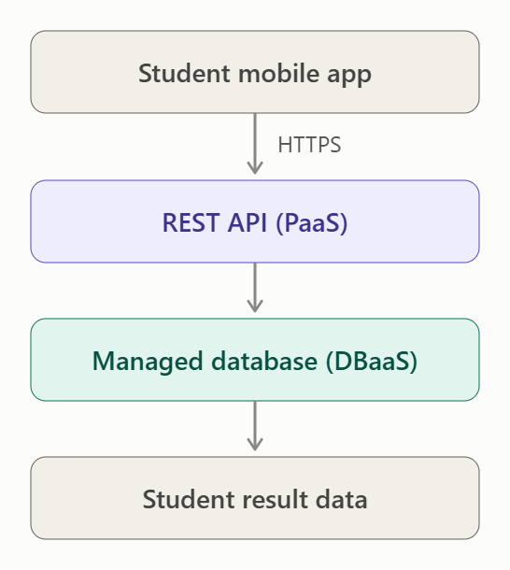
9.12. Configuration Summary
Configuration | Value
Virtualization | VirtualBox
VM OS | Ubuntu
CPU | 1 CPU
RAM | 2 GB
Storage | 15 GB
Application | Python Flask
Port | 5000
Service | Student Result API
Client | Browser / curl
Response | JSON

9.13. Issues Faced and Solutions
Issue | Solution
Flask was not installed | Installed Flask using apt/pip
Port 5000 was not accessible | Started Flask on port 5000
API was not displaying | Checked whether Flask server was running
Browser could not connect | Used 127.0.0.1:5000 inside the Ubuntu VM
JSON response was not displayed | Checked the /api/result URL

9.14. Evidence Checklist
The following screenshots should be included in the report:
- VM configuration – CPU, RAM and storage.
- Ubuntu running – guest operating system.
- Flask installation – successful installation.
- Flask server running – port 5000.
- Web page output – Smart Campus service message.
- REST API output – student result JSON.
- curl test – successful client request and response.

9.15. Result
The proof-of-concept was successfully implemented using VirtualBox, Ubuntu and Python Flask. A simple Student Result Lookup REST API was hosted inside the virtual machine and successfully tested using a web browser and curl. The implementation demonstrates the basic working of the proposed Smart Campus cloud architecture using virtualization and REST-based services.

TASK 10 – Evaluate and Recommend the Final Solution
10.1. Introduction
Based on the previous analysis, the university currently operates 12 dedicated physical servers with low average utilization and very high peak demand. The existing system has high hardware cost, slow procurement, limited scalability and no disaster recovery site.
The recommended solution is a Hybrid Cloud Architecture using:
- Type-1 virtualization for existing applications
- IaaS for legacy applications
- PaaS for modern applications and APIs
- SaaS for services such as email
- DBaaS for managed databases
- DRaaS for disaster recovery
- REST APIs for mobile and external integration
- Auto-scaling and load balancing for peak demand

10.2. Comparison of Deployment Options
Factor | On-Premise | IaaS-Based Cloud | PaaS/SaaS-Based Cloud
Initial Cost | Very high CapEx | Low CapEx | Very low CapEx
Operating Cost | Hardware, power, maintenance | Pay-as-you-use | Mostly subscription/pay-as-you-use
Scalability | Slow; new servers required | High; VMs can be added quickly | Very high; managed auto-scaling
Availability | Limited without DR site | High with multi-zone deployment | Very high with managed services
Security | Full physical control | Shared responsibility | Provider manages more infrastructure
Maintenance | University manages hardware/software | Provider manages hardware | Provider manages most infrastructure
Provisioning | Weeks | Minutes | Minutes
Skills Required | High infrastructure skills | Cloud + OS skills | Application/cloud skills
Disaster Recovery | Expensive | Easier | Usually built into managed services
Best Use | Highly controlled legacy workloads | Legacy applications | Modern scalable applications
Evaluation
The on-premise option gives maximum physical control but requires high CapEx and does not solve the university's scalability and DR problems.
IaaS provides a good migration path for existing monolithic applications because they can be moved to VMs with minimum code changes.
PaaS/SaaS provides the highest operational simplicity and scalability. However, it may introduce vendor dependency and may not be suitable for every legacy application.
Therefore, a mixed hybrid approach is more suitable than selecting only one model.

10.3. Simple 3-Year Cost Comparison
The following is an illustrative estimate, not a vendor quotation.
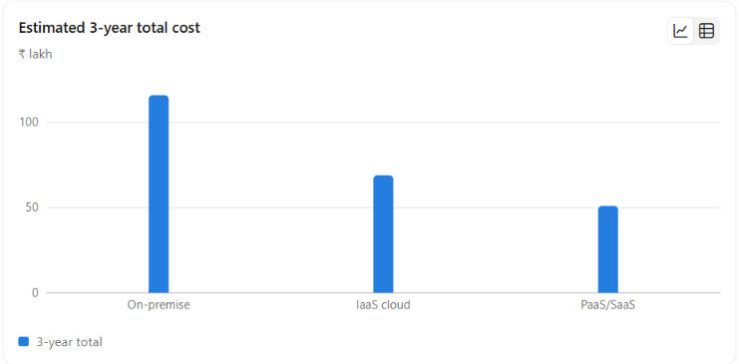
Assumptions
- 12 physical servers are required in the existing environment.
- On-premise server cost = ₹5 lakh/server.
- Additional infrastructure, networking and backup = ₹15 lakh.
- Annual power, cooling, maintenance and administration = ₹12 lakh.
- Cloud IaaS equivalent infrastructure = ₹18 lakh/year.
- Managed PaaS/SaaS services = ₹12 lakh/year.
- Migration/setup cost is estimated separately.
3-Year Estimate
Cost Component | On-Premise | IaaS Cloud | PaaS/SaaS
Initial infrastructure | ₹75 lakh | ₹5 lakh | ₹3 lakh
Migration/setup | ₹5 lakh | ₹10 lakh | ₹12 lakh
3-year operating cost | ₹36 lakh | ₹54 lakh | ₹36 lakh
Estimated 3-year total | ₹116 lakh | ₹69 lakh | ₹51 lakh
Interpretation
The on-premise solution has the highest initial CapEx.
IaaS reduces infrastructure investment and provides faster provisioning, but the university still manages operating systems and applications.
PaaS/SaaS has the lowest estimated 3-year cost in this simplified scenario because much of the infrastructure management is transferred to the provider.
Important: Actual cloud cost depends on storage, network traffic, database usage, API calls, backup requirements and the selected provider. Therefore, these figures should be treated as planning estimates.

10.4. Major Risks and Mitigation
Risk | Impact | Mitigation
Vendor lock-in | Difficult to move applications | Use containers, REST APIs, open standards and portable databases
Data privacy | Student/exam data may be exposed | Encryption, RBAC, MFA, private networks and access auditing
Cloud downtime | Service interruption | Multi-zone deployment, load balancing and DR
Skills gap | Poor cloud management | Cloud training, documentation and managed services
Cost overrun | Budget may increase | Budgets, alerts, monitoring and auto-scaling
Security attacks | Data loss or service disruption | WAF, firewalls, IAM, monitoring and regular security testing
Migration failure | Application downtime/data loss | Pilot migration, backups and rollback plans

10.5. Final Recommendation
The university should adopt a Hybrid Cloud solution instead of completely replacing all existing systems.
Recommended architecture
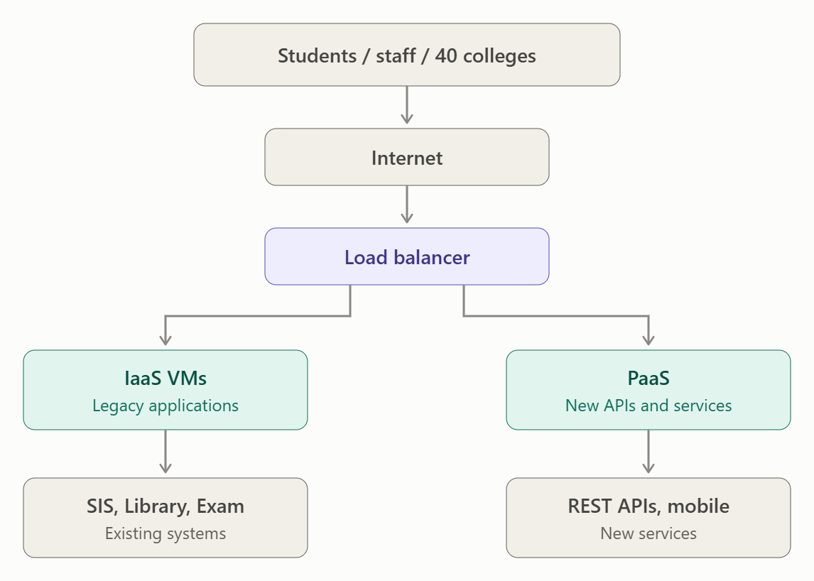

TASK 11 – Re-evaluate and Adapt the Design
11.1. Changed Requirements
The university now has four major additional requirements:
- A mobile application must be launched.
- Student-record and fee-payment services must be opened to 40 affiliated colleges.
- Expected load is 10 times the current peak load.
- System availability must be 99.9%.
- The operating budget is limited.
These requirements significantly increase the scalability, availability, security and integration requirements.

11.2. Decision: MODIFY the Existing Design
The original Hybrid Cloud Architecture should not be completely redesigned.
Instead, it should be MODIFIED and extended.
The existing design already provides:
- Hybrid cloud
- IaaS
- PaaS
- SaaS
- DBaaS
- DRaaS
- REST APIs
- Virtualization
However, the new requirements require additional components such as:
- API Gateway
- Mobile backend
- Auto-scaling
- Load balancing
- Multi-zone deployment
- API authentication
- Rate limiting
- Database replicas
- Caching
- Strong monitoring
Therefore:
RETAIN the Hybrid Cloud foundation → MODIFY it with scalable API and availability components.

11.3. Updated Architecture
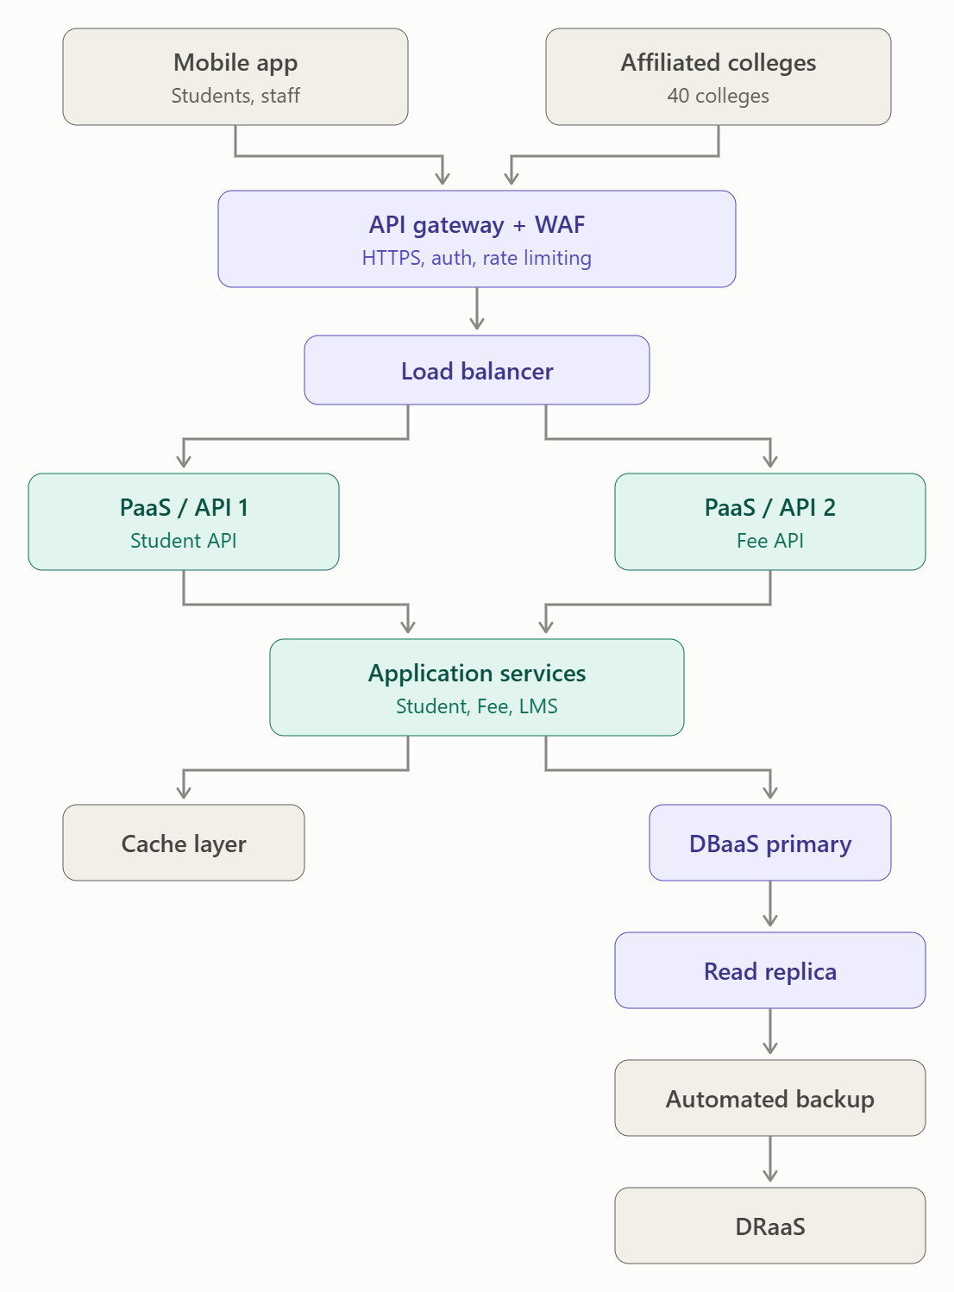

11.4. Changes Made to the Original Design
Original Design | Modified Design | Reason
REST APIs | API Gateway + REST APIs | Secure external access
Basic application tier | Auto-scaling application tier | 10× load
Single application instances | Multiple instances | High availability
Database | DBaaS + read replicas | Increased database requests
Basic internet access | WAF + authentication | Protect public APIs
Normal monitoring | Centralized monitoring | Detect failures quickly
Basic cloud deployment | Multi-zone deployment | 99.9% availability
Internal users | 40 affiliated colleges | Controlled external access
Web users | Web + mobile users | Mobile application support

11.5. Handling 10× Current Peak Load
The original system experiences peaks above 95%.
The new requirement is 10× the current peak.
A fixed number of servers would therefore not be sufficient.
Solution: Auto-Scaling
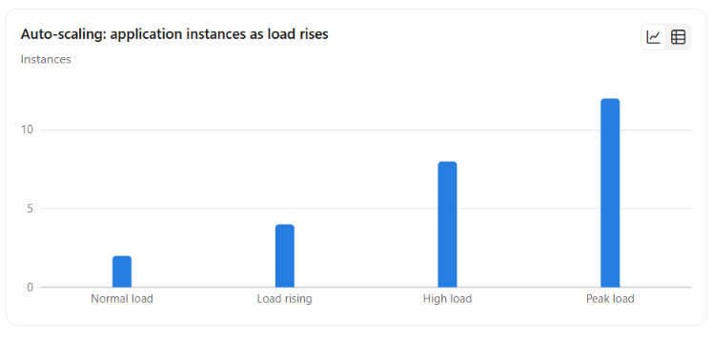The system automatically adds application instances when CPU usage, request rate or response time crosses predefined thresholds.
After the peak period, unnecessary instances are removed.
Benefit
This avoids purchasing enough physical servers for the maximum load and supports the limited operating budget.

11.6. Supporting the Mobile Application
The mobile application should not directly access the university database.
Instead:
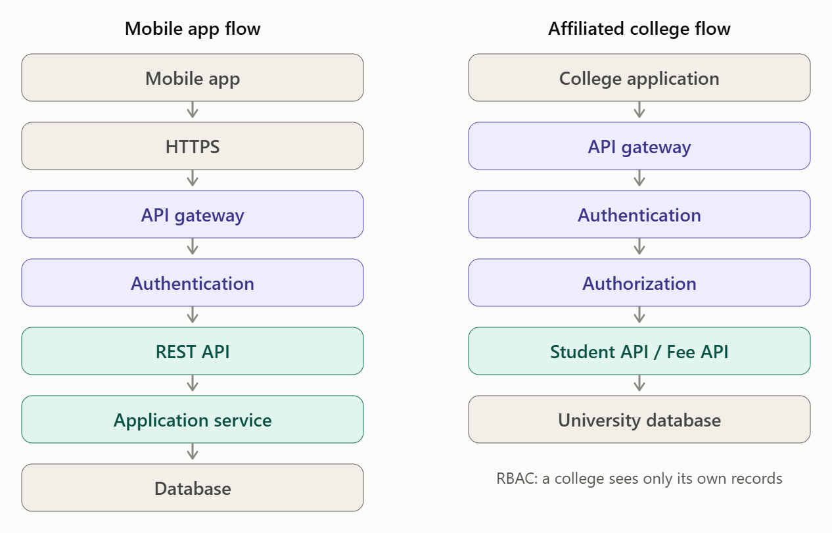The API Gateway provides:
- Authentication
- Authorization
- Rate limiting
- Request validation
- API monitoring
- Traffic control
This protects the internal university systems.

11.7. Supporting 40 Affiliated Colleges
Each affiliated college should receive controlled access to only the required services.
For example:
College Application
↓
API Gateway
↓
Authentication
↓
Authorization
↓
Student API / Fee API
↓
University Database
Role-based access control should ensure that one college cannot access another college's student records.
Additional controls:
- OAuth 2.0 / token-based authentication
- HTTPS/TLS
- API keys or client credentials
- Rate limiting
- Audit logs
- IP restrictions where appropriate

11.8. Achieving 99.9% Availability
The new availability requirement is 99.9%.
The design should avoid single points of failure.
Proposed solution
- Deploy application instances across multiple availability zones.
- Use a load balancer.
- Use replicated databases.
- Use automated backups.
- Use health checks.
- Use DRaaS for disaster recovery.
- Monitor applications continuously.
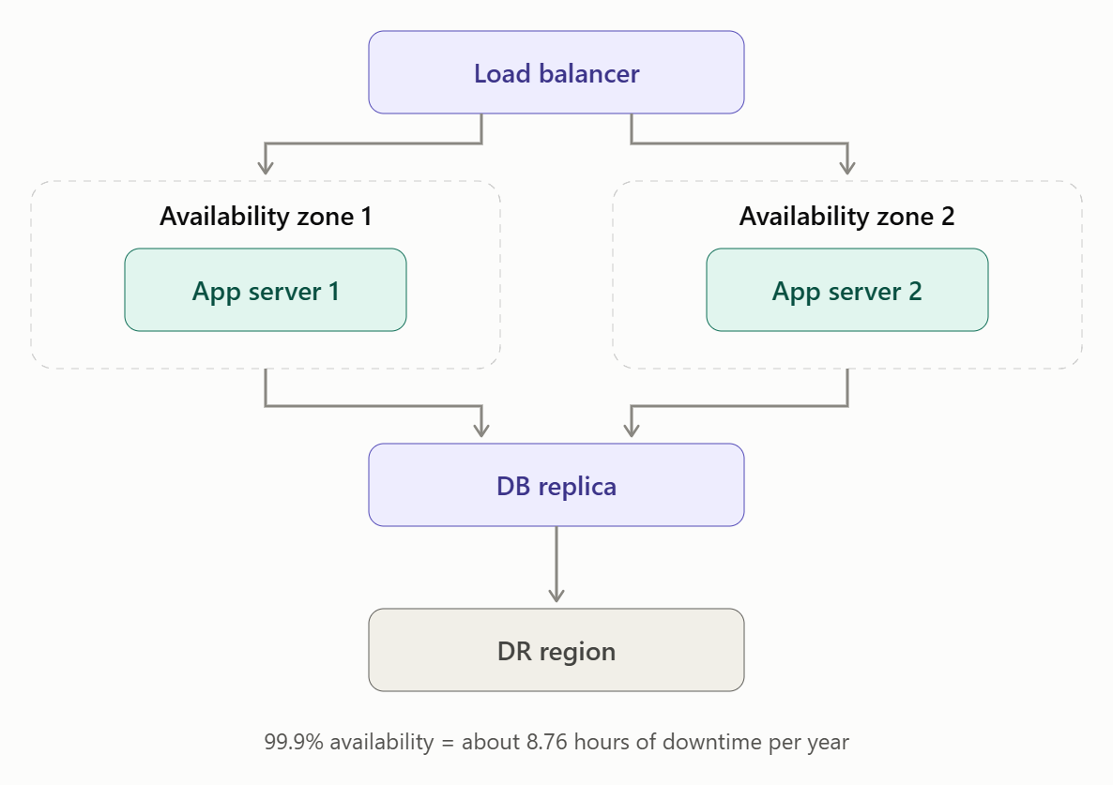
99.9% availability allows approximately 8.76 hours of downtime per year, so monitoring and failover mechanisms are important.

11.9. Database Modification
The database becomes a major bottleneck when load increases 10 times.
The original DBaaS design should therefore be enhanced with:
- Primary database
- Read replicas
- Automated backups
- Encryption
- Automatic failover
- Database monitoring
- Caching
Example
Student-result requests are mainly read operations.
Therefore:
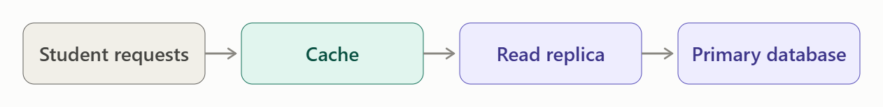Caching and read replicas reduce pressure on the primary database.

11.10. Security Changes
Because services are now exposed to 40 external colleges, security must be strengthened.
Security controls
- HTTPS/TLS for all communication.
- API Gateway.
- Web Application Firewall.
- Multi-factor authentication for administrators.
- Role-Based Access Control.
- Encryption at rest.
- Encryption in transit.
- API rate limiting.
- Centralized logging.
- Regular security testing.
Sensitive student and payment information should remain in protected/private database networks.

11.11. Budget Considerations
The university has a limited operating budget.
Therefore, the design should avoid permanently running resources for the maximum 10× load.
Cost optimization
- Use auto-scaling.
- Use pay-as-you-use cloud resources.
- Scale down after peak periods.
- Use managed PaaS instead of managing many servers.
- Use DBaaS instead of maintaining database hardware.
- Monitor cloud usage.
- Set budget alerts.
- Use storage lifecycle policies.
- Avoid unnecessary always-on resources.
This allows the university to handle high demand without paying maximum capacity throughout the year.

11.12. Re-evaluated Architecture
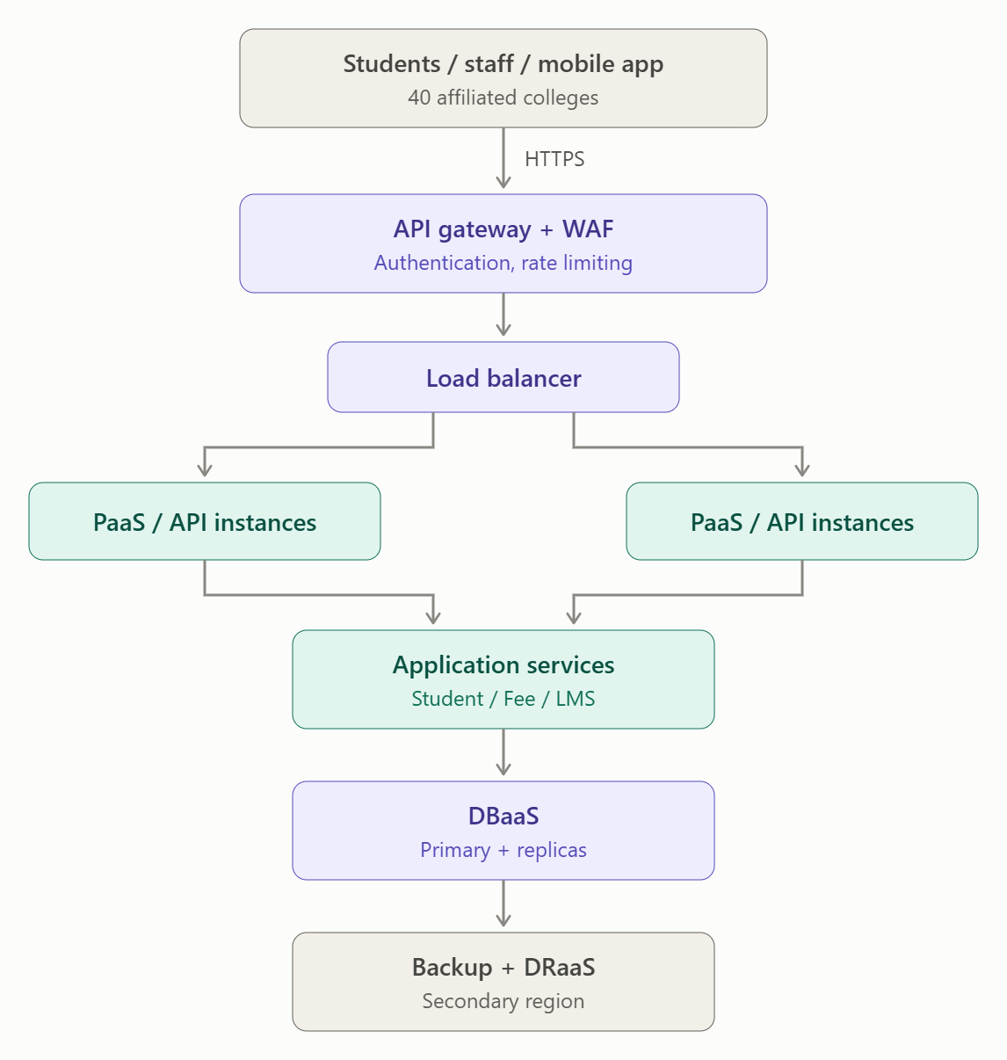

11.13. Final Recommendation for Day-4 Challenge
The original Hybrid Cloud Architecture should be retained and modified, not completely redesigned.
Main modifications:
- Add API Gateway for mobile and affiliated-college access.
- Add WAF and authentication for security.
- Add load balancing.
- Add auto-scaling to handle 10× peak load.
- Use multi-zone application deployment.
- Upgrade DBaaS with read replicas and failover.
- Use caching to reduce database load.
- Use DRaaS and automated backups.
- Apply rate limiting and RBAC for 40 colleges.
- Use pay-as-you-use resources to control operating costs.
Conclusion
The changed requirements do not require a completely new architecture. The existing hybrid cloud design provides a strong foundation, but it must be enhanced with API management, auto-scaling, load balancing, database replication, caching, multi-zone deployment and stronger security.
This modified architecture can support the mobile application, 40 affiliated colleges and 10× peak load while targeting 99.9% availability and controlling operating costs.

Impact Analysis – 2 Marks
Discuss:
- What has changed from the original problem
- Which original assumptions (load, users, availability, cost) are affected
- Why the web services and APIs now become critical
- How multi-tenant access by 40 colleges affects security and isolation
Evidence Expected: A clear analysis of how the changed requirements affect the original cloud design.
Evaluation of the Original Design – 2 Marks
Discuss:
- Whether the chosen service models and virtualization plan can handle a 10x load
- Whether auto-scaling and the single-region deployment are sufficient for 99.9% availability (about 8.76 hours of downtime allowed per year)
- Whether cost remains acceptable under the new load
- Whether another service model or XaaS offering would give better overall results
Evidence Expected: A technically supported evaluation of the original design under the new conditions.
Adaptation or Redesign – 2 Marks
Discuss:
- Decide whether to retain, modify or redesign the solution
- Describe the revised architecture (for example API gateway, container orchestration, serverless components, multi-zone deployment or a hybrid model)
- Explain what changed in the service model mix and in the virtualization approach
- If you retain the original design, give sufficient technical justification for why no change is required
Evidence Expected: An appropriate design response to the changed requirement, with clear technical reasoning.
Evidence-Based Defence – 2 Marks
Discuss:
- Capacity and availability calculations
- Cost comparison between the original and the revised design
- Security and multi-tenancy considerations
- Trade-offs such as vendor lock-in, complexity and migration effort
Evidence Expected: A well-supported final decision that follows logically from the analysis.
MARK DISTRIBUTION
Task | Title | Bloom's Level | Marks
Task 1 | Cloud Computing – Introduction & Characteristics | L2 – Understand | 3
Task 2 | Evolution & Hardware Evolution | L2 – Understand | 3
Task 3 | Internet Software Evolution | L2 – Understand | 3
Task 4 | Server Virtualization | L3 – Apply | 5
Task 5 | Web Services | L3 – Apply | 4
Task 6 | Service Models: IaaS, PaaS, SaaS | L4 – Analyze | 5
Task 7 | XaaS | L4 – Analyze | 3
Task 8 | Design the Cloud Solution Architecture | L6 – Create | 5
Task 9 | Hands-on Implementation & Documentation | L3 – Apply | 4
Task 10 | Evaluate & Recommend the Final Solution | L5 – Evaluate | 7
 | Subtotal

Task 11 | Day-4 Design Challenge | L4 / L5 / L6 | 8
 | TOTAL |  | 50

